**Course Description Form**

**Course Description Mathematics**

|  |
| --- |
| This course description provides a concise summary of the main features of the course and the learning outcomes expected of the student, demonstrating whether he or she has made the most of the learning opportunities available. It must be linked to the programme description **.** |

1. Educational Institution / Shatt Al-Arab University

2. Scientific Department / Center / Department of Fuel and Energy Technology Engineering

3. Course Name/Code

4. Available attendance forms / Weekly

5. Semester / Year / Semester 2024- 2025

6. Number of study hours (total) / 150

7. Date of preparation of this description / 5 - 10 - 2024

8. Course objectives :

1. Develop problem solving skills and understanding of calculus.

2. Understand vectors, vector function and their applications.

3. Identify complex numbers and apply them in mathematical problems.

4. Apply partial differentiation and solve problems with multiple variables.

5. Learn and use double and polar integration to calculate areas and volumes.

6. Understand theories such as Green’s Theorem and Divergence Theorem and use them in engineering applications.

7. Solve first-order and higher-order differential equations.

|  |
| --- |
| 1. Course outcomes, teaching, learning and assessment methods :   Knowledge and understanding (cognitive objectives):  A1- Understanding the concept of differentiation and integration and applying them in advanced problems.  A2- Solving linear and plane equations in space using vectors.  A3- Learn partial differentiation, Taylor and Maclaurin series and use them in mathematical analysis.  A4- Understand double and polar integration and calculate areas and volumes using these methods.  A5- Solving complex problems using matrices and differential equations. |
| B - Course specific skill objectives .  B1 - Ability to solve differential and integral calculus problems.  B2 - Applying mathematical concepts in engineering and physical analysis problems.  B3 - Ability to deal with complex numbers and their applications.  B4- Learn to draw curves using polar coordinates and engineering applications. |
| Teaching and learning methods |
| • Theoretical lectures to clarify basic concepts.  • Solve exercises and practical problems to enhance theoretical understanding.  • Group projects to apply mathematical concepts to real-world problems.  • Use mathematical software to solve complex problems. |
| Evaluation methods  • Quizzes and assignments .  • Midterm exam to assess students' understanding during the semester.  • Final exam to measure students’ comprehension of all course topics.  • Projects and practical applications that contribute to the development of analytical skills. |
| * Regular and surprise theoretical tests . * Homework and practical tests. * Reports and studies (non-mandatory ). |
| C- Emotional and value-based goals  A1- Developing analysis and inference skills.  A2- Enhancing critical thinking and independent thinking.  A3- Developing the ability to work in a team and participate effectively.  A4- Motivating students to think outside the box and apply mathematical theories to solve real-world problems. |
| and transferable skills ( other skills related to employability and personal development).  D1- Developing the student’s leadership skills.  D2- Developing the student’s mental fitness during the lecture by constantly asking questions.  D3- Developing skills in the basics of electrical engineering and in the field of electrical circuit theory.  D4- Developing the student’s language skills to increase his ability to express his ideas.  D5- Developing the student ’s skills in designing and testing circuits using electronic circuit simulator applications .  D6- Developing the skill of using Measuring devices and their initial maintenance at the student's place. |

Course structure

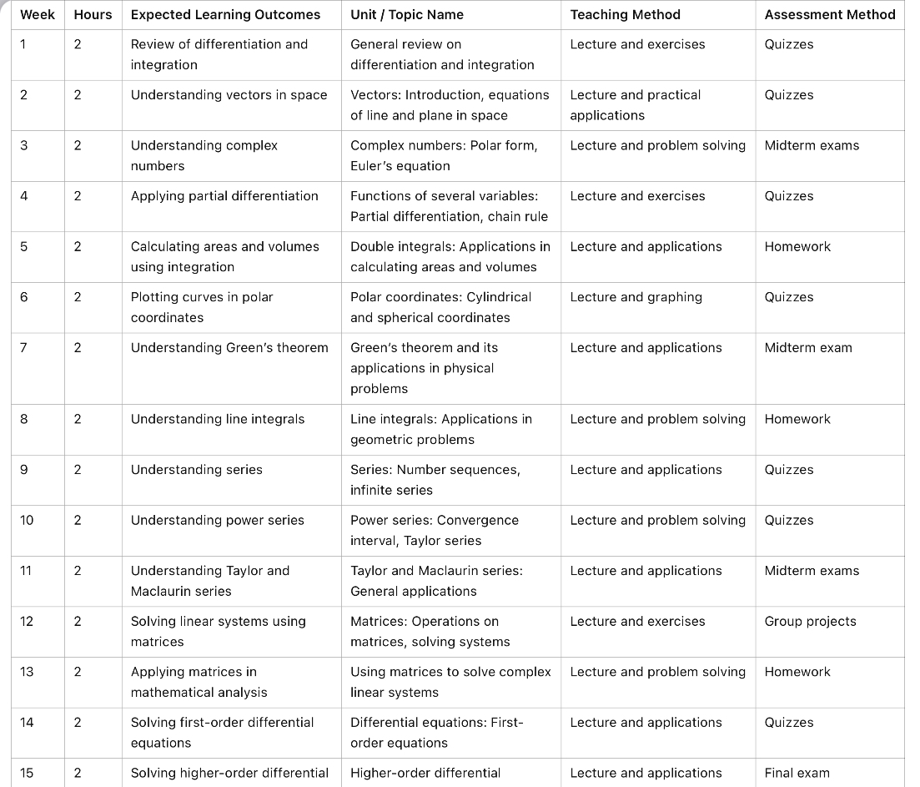

|  |  |
| --- | --- |
| 1. Infrastructure | |
| 1- Required textbooks | **Calculus and Analytic Geometry" by G. Thomas and R. Finney, Sixth Edition, 2008.** |
| 2- Main references (sources) | **• “ Mathematical Methods for Science Students” by G. Stephenson, Longman House, 1981.** |
| A- Recommended books and references ( Scientific journals, reports,.... ) |  |
| B - Electronic references, websites... | 1. Google Scholar, Khan Academy, Coursera. |

|  |
| --- |
| 1. Curriculum development plan   Introducing modern applications of mathematical topics such as numerical analysis and big data .  Promote the use of mathematical software in solving complex problems . |