


Marketing and Management for Oil and Gas Department
The scientific curriculum for the subject:
) Management Information System (
Academic Level
) Second Year (
Semester
)Second Semester(
Academic Year
( 2026 – 2025 )

اسم الجامعة: جامعة البصرة للنفط والغاز
الكلية: كلية الإدارة الصناعية
القسم العلمي: قسم إدارة وتسويق النفط والغاز
اسم البرنامج الأكاديمي او المهني: بكالوريوس إدارة وتسويق النفط والغاز
اسم الشهادة النهائية: بكالوريوس في إدارة وتسويق النفط والغاز
النظام الدراسي: فصلي
اسم المادة: نظم المعلومات الادارية
تاريخ اعداد المنهاج: 1/2/2026

اسم وتوقيع مدرس المادة: م.م. منتظر عريبي جاسم

-----------------------------------------------------------------------------------------------------------------------

اسم وتوقيع مدرس المادة:

--------------------------------------------------------------------------------------------------------------

بنية المقرر الدراسي
العنوان | الاسبوع | ت
 | الأسبوع 1 | 1
 | الأسبوع 2 | 2
 | الأسبوع 3 | 3
 | الأسبوع 4 | 4
 | الأسبوع 5 | 5
 | الأسبوع 6 | 6
 | الأسبوع 7 | 7
 | الأسبوع 8 | 8
 | الأسبوع 9 | 9
 | الأسبوع 10 | 10
 | الأسبوع 11 | 11
 | الأسبوع 12 | 12
 | الأسبوع 13 | 13
 | الأسبوع 14 | 14
 | الأسبوع 15 | 15

Scientific material for the first week
Introduction to Management Information Systems

- Information Systems Concept
  - Information systems (IS):
Are interconnected sets of components (people, hardware, software, data, and processes) that work together to collect, process, store, and distribute data and transform it into useful information. These systems aim to support decision-making, coordination, and control within organizations, as well as to analyze data to improve operational and strategic performance.

  - Management Information Systems (MIS):
These are computerized systems that collect, store, and process data (internal and external) to transform it into accurate information that supports managers in decision-making, planning, and control. These systems link business administration with information technology to streamline processes and improve operational efficiency within organizations.

- Approaches to the study of management information systems
The main approaches to Management Information Systems (MIS) consist of three complementary dimensions: the organizational approach (processes and culture), the managerial approach (decision support), and the technological approach (hardware and software). These approaches work together to link business management with information technology, aiming to improve organizational performance, collect data, and process it to support various management levels.

The study of Management Information Systems (MIS) falls within a multidisciplinary field, as no single theory fully explains the system. It is approached through four main approaches that integrate to form a comprehensive understanding:
  - The Administrative Approach: This approach focuses on mathematical models and the physical capabilities of systems.
- Computer Science: Focuses on computing theories and methods for storing and accessing data effectively.
- Management Science: Focuses on developing models for decision-making and administrative practices.
- Operations Research: Emphasizes mathematical techniques for improving organizational metrics such as inventory and transaction costs.
  - The Economic Approach: This approach focuses on two fundamental economic theories in systems management:
- Transaction Cost Theory: Information systems help reduce transaction costs (such as supplier sourcing, negotiation, and contracting) through online and digital platforms, thus reducing the organization's need for vertical expansion and making it more agile.
- Agency Theory: As an organization grows, the cost of monitoring employees (agents) increases. An information system acts as an effective control tool, ensuring that employee goals align with owners' goals, thereby reducing agency costs.
  - The Technical Approach: The technical approach to management information systems focuses on the physical aspects and rigorous mathematical models, neglecting human or behavioral variables. This approach views the system as a set of technological capabilities aimed at improving efficiency through precise computing.
  - The Socio-technical Approach: - It is the newest and most comprehensive approach, as it sees that the system’s performance peaks when both technology and social aspects (people and tasks) are jointly improved. The basic idea is (technology cannot succeed if the needs of employees or the culture of the organization are ignored, and vice versa).
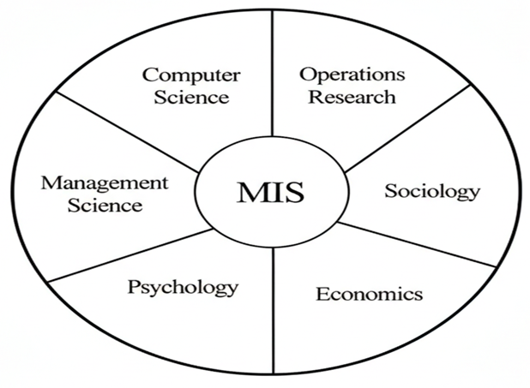

- Analysis of the concept of management information systems
Management Information Systems (MIS) constitute an integrated organizational, technical, human, and administrative structure of computer components, programs, networks, and databases that work with human resources of knowledge workers within an organized and coordinated context to support administrative processes and activities, and in particular to support unstructured (non-programmed) and semi-structured (semi-programmed) administrative decision-making processes.

Scope of Management Information Systems
- A Hybrid and Integrated System: The system is not limited to hardware alone, but rather combines four dimensions (technical, organizational, human, and administrative).
- Knowledge Resource Management: The system works with "knowledge workers" (specialized employees) to transform raw data into useful knowledge within the organizational context.
- Support for Complex Decisions: It focuses specifically on:
- Unstructured Decisions: These are unique decisions that do not have ready-made solutions and require human judgment.
- Semi-structured Decisions: These are decisions where the computer provides part of the solution, and the manager completes the other part.
- Dual Support: Providing direct support (instant reports) and indirect support (analysis of historical data).
- Network Architecture: Full reliance on the Internet, Intranet (for internal employees), and Extranet (for dealing with suppliers and partners).
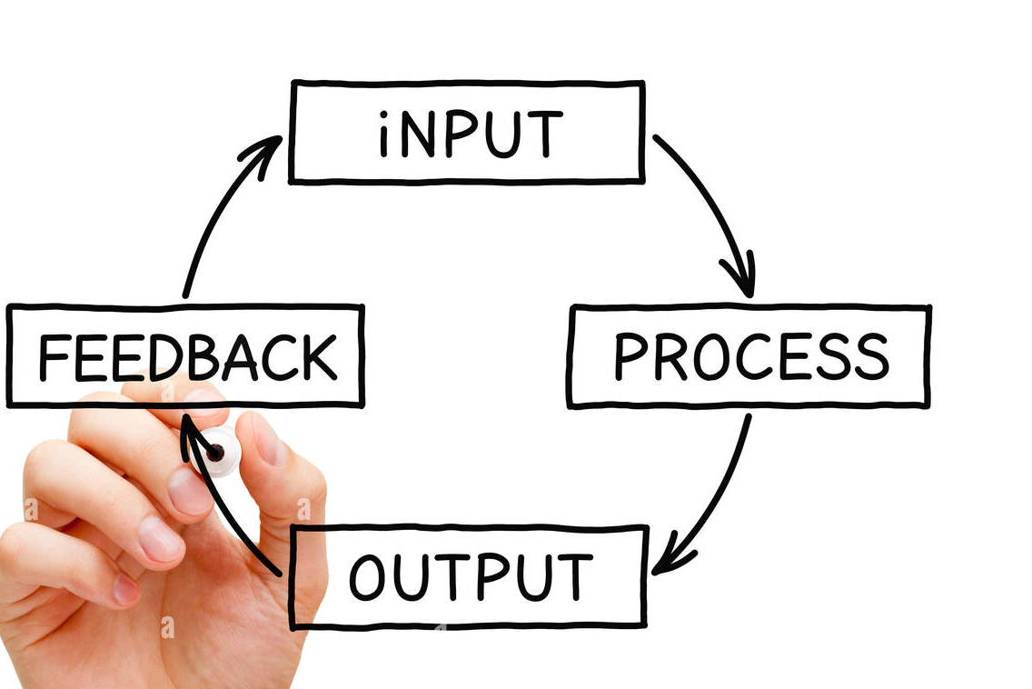

Scientific material for the second week
Management Information Systems (MIS) Study Environment

- The Study Environment of Management Information Systems
The study environment of Management Information Systems (MIS) is one of the most dynamic and exciting fields, as it combines two different worlds: management and technology.
That is, it is not limited to programming alone, nor is it purely business administration; rather, it is the bridge between them because it focuses on the following aspects:
  - Technical Aspect: Databases (SQL), Systems Analysis and Design, Information Security, and Computer Networks.
  - Administrative Aspect: Principles of Management, Marketing, Accounting, and Organizational Behavior.
  - Smart Connectivity: How to Use Technology to Solve Business Problems and Make Data-Driven Decisions.

Skills required in a learning environment
- Analytical Thinking: The ability to break down a complex business problem and transform it into a technical solution.
- Communication Skills: You will learn how to be a "translator" who explains technical matters to managers and administrative requirements to programmers.
- Teamwork: Most course projects are conducted in groups to simulate the real-world work environment in companies.

- Information Systems, Information Technology, and Management Information Systems
The historical and conceptual relationship between Information Systems (IS), Information Technology (IT), and Management Information Systems (MIS) can be summarized as follows:
  - Historical Roots and Origins
- The Age of the Computer: The text indicates that the history of the computer is relatively short (not exceeding six decades), having originated within the military establishment before transitioning to civilian and commercial activities.
- The Emergence of the Term MIS: The features of "Management Information Systems" began to take shape between 1967 and the 1970s. During that period, this term predated the term "Information Technology."

  - The Shift from Computers to Management
- Initially, these systems were known as Computer-Based Information Systems (CBIS), and their primary objective was to support administrative processes and management activities.
- These systems became the "lifeblood" of organizations; banks, insurance companies, and factories cannot continue operating today without Management Information Systems.

  - The 1980s Revolution and the Rise of Information Technology (IT)
- The 1980s witnessed a qualitative leap with the personal computer revolution.
- This development led to the emergence of the term Information Technology (IT) to describe the tools and technologies (networks, digital media, databases) that accompanied the "information explosion."
- These technologies subsequently developed rapidly (exponentially) to encompass broader areas than simply supporting management.
Summary: Definition of Management Information Systems (MIS)
- Management Information Systems is defined as a theoretical and practical field that combines various disciplines:
- Sources: (Computer Science, Information Technology, Management, Organization, Economics, and Quantitative and Behavioral Sciences).
- Basic Principle: Any computerized information system designed to support an organization's systems and processes falls under the umbrella of MIS.
(Key difference: While IT focuses on tools (hardware and software), MIS focuses on how to leverage these tools to serve business and management objectives.)

- Information systems and general systems theory
The Fundamental Principles of Systems Theory
There is a set of fundamental principles that form the common fabric of general systems theory, namely:
- The System : A system is defined as a whole composed of interconnected and integrated elements and parts. Systems in general, whether social, human, biological, or mechanical, consist of interacting and interconnected elements.
- Subsystems : Information systems consist of several interconnected subsystems that work together to achieve the organization's goals. The most prominent of these are the Transaction Processing System (TPS), Management Information Systems (MIS), Decision Support Systems (DSS), and Executive Information Systems (EIS). These systems are classified based on their functions (production, marketing, human resources, accounting) or the administrative activities that support decision-making, control, and communication.
- Consistency : Systems are characterized by internal consistency. This consistency is represented by the structure of the system itself, that is, the homogeneity of the structure of its components and parts. This consistency is clearly demonstrated in the phenomenon of integrating the desired goals that the system seeks to achieve within the framework of the environment in which it operates.
- Integrity and Comprehensiveness : A system is not merely an assembly of separate parts, but a comprehensive framework. The strength of a system lies in the interaction between its components. The complementary relationship between the parts is what enables the system to function as a unified whole to achieve a specific goal, sometimes referred to as "team spirit" in automated or administrative work.
- Adaptation : This section distinguishes between two types of systems based on their relationship to the surrounding environment:
- Open Systems: These are systems that interact with the external environment, exchanging data, energy, and information. Adaptation is a vital characteristic here because it allows the system to modify itself based on external variables to survive and continue.
- Closed Systems: These are systems that do not have relationships with the environment. An information system can only be open because closure leads to a loss of balance, an inability to achieve goals, and even the "death" of the system technically.
- Inputs, Processes, and Outputs : Every system has inputs, processing operations, and outputs. Systems differ in the nature of their inputs, processes, and output characteristics, as illustrated in the following figure.
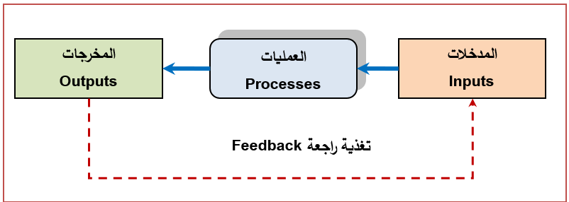
- Feedback is defined as the process of correcting deviations and errors that may occur during system operation. It acts as a form of self-monitoring, ensuring the system stays on track.
- Importance of Feedback: a) Increased Efficiency: Ensuring the system operates optimally to achieve its objectives.
- Gap Closure: Measuring the difference between actual performance (what actually happened) and target standards (what should have happened) and then correcting it.
- Continuity: Without feedback, the system model is incomplete; it is what gives it vitality and allows it to renew itself.
- System Boundaries : Systems have imaginary, virtual, or organizational boundaries, but these are often intangible and separate the system from its environment and from other systems operating within the same environment. Every system, including information systems, operates within a specific organizational framework, and everything outside this framework constitutes an external environment. In the context of analyzing, designing, and developing information systems, it is crucial to understand the boundaries of each system within its operating environment, as well as the boundaries and relationships of each subsystem or structural unit within the larger system structure.
- System Interface : This is the point or area where different systems meet. It acts as a medium for transferring or converting outputs from one system to become inputs for another. It provides simplicity and ease of use for the end user, appearing as an interactive interface for the system.
- Hierarchical Systems : Systems are linked by hierarchical relationships with each other, meaning that systems in general (and information systems in particular) are layered hierarchically, or they are systems with a hierarchical structure by virtue of their nature, composition, and main and branching functions.

Scientific material for the third week
Information systems development

- Factors Influencing the Development of Information Systems
  - The Emergence of the Information and Knowledge Revolution
- The Information Explosion: This refers to the massive and rapid increase in the amount of information produced, to the point that it accumulates at rates exceeding human capacity to keep up with or process it manually.
- The Global Village: This term describes how technology has made the world highly interconnected, where distances and borders have virtually disappeared thanks to rapid communication, making the distant feel as close as your neighbor in the village.
- The Knowledge Economy: This is an economic system that relies on ideas, innovation, and intelligence (information) as the primary source of wealth, instead of relying entirely on natural resources or traditional factories.
- Digitization: This is the process of converting information (text, images, sounds) from its traditional physical form into a digital programming language that computers understand, thus facilitating its storage and transmission at extremely high speeds.
- The Information Society: This is a society whose members' activities and development are fundamentally based on the exchange of information and the use of technology in all aspects of daily life and work.
  - Internet and Network Technology
- Data Management and Processing: Technology (hardware and software) enables the management of massive amounts of data through database management systems, ensuring accuracy and rapid retrieval.
- Improved Decision-Making: Technology- and internet-based information systems provide real-time and accurate analytical data, helping management make fact-based decisions.
- Enhanced Communication and Collaboration: The internet, through email and social networks, facilitates rapid interaction between employees and clients and supports remote work.
- Process Automation and Productivity: Technology replaces manual processes, reducing human error and increasing operational efficiency.
- Shift from Physical to Cloud Storage: Cloud computing technologies have enabled information systems to store enormous amounts of data without the need for physical space, while ensuring retrieval from any device at any time.

  - E-Business Models
E-business models have revolutionized Information Systems (IS) by transforming them from traditional operational tools into strategic engines that have contributed to the development of Management Information Systems (MIS) through the following models:
- Focused Distributor Models: These e-business models include the Retailer Model, the Marketplace Model, the Information Mediary Model, and the Exchange Model.
- Portal Models: These models consist of the following applications: Horizontal Portals, Vertical Portals, and Affinity Portals.
- Producer Models: These models include the Manufacturers Model, the Service Providers Model, the Educators Model, Advisors, Information and News Service Providers, and Customized Providers.
- Infrastructure providers Models: These include Equipment Component Manufacturers, Software firms Model, and Custom Hardware Suppliers.

  - Globalization
Globalization has reshaped information systems by integrating technology and the internet, creating a "global village" that enables the rapid exchange of data and knowledge, transcending geographical boundaries. It has contributed to the development of Geographic Information Systems (GIS) to enhance supply chains, improve logistics processes, and increase international competitiveness through technology innovation and deployment.

Key aspects of globalization in information systems include:
- Supply chain integration: Geographic Information Systems (GIS) are integrated into logistics processes to track shipments and inventory globally, reducing time and costs.
- Information and idea exchange: The globalization of media has transformed ways of cultural interaction, relying on smart networks for real-time data transfer.
- Technology diffusion: Globalization facilitates the spread of technologies from developed to developing countries, boosting competition and driving innovation.
- Workflow software: The emergence of software that integrates applications and databases facilitates collaboration and cross-border work.
  - The Acceleration of Qualitative and Quantitative Change in the Business Environment
We live in a world characterized by rapid qualitative and quantitative changes in all fields. Among the most prominent features of this change are:
- Blurring of Boundaries: The dissolution of temporal and spatial boundaries between what exists and what will be created in new forms and content.
- Development of the Technological Environment: This change is clearly evident in the fields of biotechnology, genetic engineering, and complex software engineering.
- Competitive Power: In light of these transformations, "information" has become the constant law, and the essence of competitive advantage lies in the value of the available information.

- Information Systems and Business
Information Systems and Business is a discipline that integrates information technology and business administration, with the aim of designing and managing computerized systems that collect, store, and process data to support managerial decision-making, improve operational efficiency, and enhance the competitiveness of companies through the use of technology.

  - The Importance of Information Systems in Business:
- Decision Support: Decision Support Systems (DSS) provide data analysis to help managers make informed decisions.
- Operational Efficiency: They are used in supply chain management, shipment tracking, and optimizing transportation routes to reduce costs.
- Transaction Processing: They organize and accurately document daily operations.
- Competitive Advantage: They contribute to market analysis and interaction with customers and suppliers.

  - Types of Basic Business Information Systems
- ERP (Enterprise Resource Planning): To connect all company departments (finance, human resources, production) in a single system.
- CRM (Customer Relationship Management): To track customer data and improve sales and service.
- SCM (Supply Chain Management): To organize the flow of goods from the supplier to the end consumer.
- DSS (Decision Support Systems): Analytical tools to help senior management solve complex problems.

Scientific material for the fourth week
Management Information Systems and Organizational Levels

- Organizational Levels and Their Corresponding Information Systems
This concept focuses on how information systems are designed to serve the different needs of each level in the management hierarchy. Each level requires a specific type of data to make its decisions.
Organizations are typically divided into three main levels, each with its own Management Information System (MIS):

  - Strategic Level (Top Management)
System Type: (This system is for top management) (Management Support Systems)
Objective: To make unstructured, long-term decisions (such as expanding into new markets). It relies on summarized external and internal data.

  - Tactical Level (Middle Management)
System Type: DSS/MIS (Decision Support Systems)
Objective: Monitoring performance, budgets, and making medium-term decisions. Relies on periodic reports and benchmarks.

  - Operational Level (Lower Management)
System Type: TPS (Transaction Processing Systems)
Objective: Recording routine daily operations (such as sales, inventory, and payroll). It is the primary data source for higher-level systems.

- The Strategic Role of Management Information Systems (MIS):
Information flows from the bottom up. Transactional Systems (TPS) collect raw data, which is then summarized and transformed into reports by higher-level systems (MIS & DSS). These reports are then passed on to senior management, who use this summary to make strategic decisions that ensure the organization's competitiveness.
Target Audience: Senior Management (Board of Directors, CEO).
Nature of Work: Focuses on long-term planning (3-5 years) and formulating the organization's overall vision.

Key Tasks:
- Internal Environment Analysis (Strengths and Weaknesses).
- External Environment Analysis (Market Opportunities and Threats and Competition)
- Systems Used: Strategic Information Systems (SIS): Aims to increase competitive advantage.

Characteristics of Information at this Level:
- Unstructured: Deals with unique problems that do not have predefined, routine solutions.
- External Source: Relies heavily on data from outside the organization (regulations, competitors, the economy).
- Future-oriented: Focuses on forecasts and plans for several years ahead rather than daily operations.

- The Strategic Dimensions of Management Information Systems
The "strategic dimensions" of Management Information Systems are the axis that transforms these systems from mere tools for managing daily operations into competitive weapons that ensure the organization's survival and growth.

  - Competitive Advantage Dimension
This dimension is the most important at the strategic level, as the systems work to:
- Differentiate Products: Use technology to offer unique services or goods that competitors cannot easily imitate.
- Reduce Costs: Achieve high operational efficiency, allowing the organization to sell at lower prices than competitors while maintaining profitability.
- Focus on a Specific Market Segment: Use deep data analysis to precisely target specific customer segments.

  - The analytical dimension (Strategic Analysis - SWOT)
The system plays a pivotal role in:
- Analyzing the internal environment: identifying strengths (such as operational efficiency) and weaknesses (such as resource shortages).
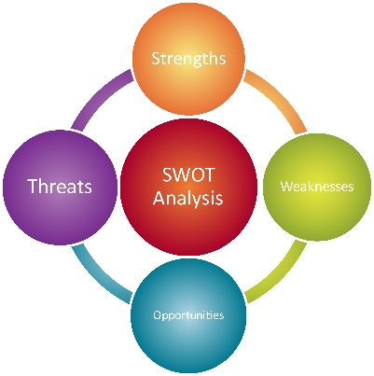
- Analyzing the external environment: forecasting future opportunities and warning of potential threats in the market, thus helping senior management formulate proactive strategies rather than simply reacting to them.

  - Strategic Decision Support
In this dimension, systems don't just provide abstract data, but also:
- What-if Analysis: Helping leaders visualize the potential outcomes of their decisions before actually making them.
- Comprehensive Vision: Connecting all departments within the organization to ensure that strategic decisions serve the best interests of the entire organization and don't create disruption in any specific sector.
  - Innovation
The strategic role of information systems enables:
- The creation of new business models: Such as the shift from traditional sales to digital platforms.
- Accelerating the product lifecycle: Reducing the time required from the idea stage to product launch thanks to the rapid flow of information.

- Information Systems and Competitive Advantage
Information systems serve as a strategic tool for achieving a proven competitive advantage through two avenues:
- External Sources: Providing information about the main competitive forces in the external environment.
- Internal Sources: Providing information about the "value chain" activities within the organization's environment.

Analysis of Competitive Forces According to Porter's Model
The nature and degree of competition in any industry depend on five fundamental forces (Porter's model):
- Competition Among Existing Firms: This is the central factor that determines the industry's attractiveness.
- Threats of New Entrants: The entry of new companies into the market.
- Bargaining Power of Suppliers: The extent to which suppliers control prices and terms.
- Bargaining Power of Buyers: The ability of customers to pressure for lower prices.
- Threats of New Products and Services: The emergence of substitutes that replace the original product.

Scientific material for the fifth week
Information functional subsystems

Information functional subsystems
Information systems take on multiple forms and dimensions depending on an organization's needs and environmental conditions:
- Functional diversity: Systems are structured according to their area of ​​operation, such as marketing, operations, accounting, and finance.
- Integration: These functional subsystems can together form an integrated framework for the organization's management information system.
- Flexibility: The nature of these systems changes according to the desired organizational goals and the nature of the organization.

Information systems come in many forms depending on the function they serve and the needs of the organization and its environment. These systems can be integrated to form a comprehensive management system.
- A Marketing Information System (MIS) is an integrated structure of people, equipment, and software designed to generate a flow of marketing information from internal and external sources to support decision-making.
- Functions: Sales forecasting, marketing research, and consumer behavior research.
- Subcomponents: Includes subsystems for data processing, forecasting, promotion and advertising, and consumer research.
- Outputs: Reports on the marketing mix, consumer behavior, current and projected sales, and market trends.
- Operations Information Subsystem (OIS)
A computer system that provides and manages the Management Information System (MIS) with organized and accurate information about the normal flow of operations, materials, and products.
- Technical Integration: Integrates with systems such as Computer-Aided Design (CAD), Computer-Aided Manufacturing (CAM), and robotics systems.
- Outputs: Reports on the product mix, production rates, total quality management, logistics operations, and industrial safety and security.

- Human Resources Information System (HRIS)
Aims to meet management's information needs regarding all employees.
- Supported Functions: Recruitment and hiring, training, compensation and incentives, and performance appraisal.
- Importance: Contributes to improving the efficiency and effectiveness of human capital and knowledge production within the organization.

Most of these resource systems (marketing, finance, human) follow a standardized structure based on:
- Inputs: Raw data from internal and external sources.
- Processes: Data processing and storage in specialized databases.
- Outputs: Informative reports that support the strategic and tactical objectives of management.

- Accounting and Financial Information System
This system is a vital component of the functional subsystems that collectively form the integrated management information system within an organization.
The system processes financial and accounting data generated from daily operations, transforming it into useful information that supports financial decision-making.
The accounting and financial system is divided into several specialized subsystems that serve specific objectives:
- The Accounting Recording Subsystem: To document all financial transactions as they occur.
- The Auditing Subsystem: To ensure the integrity of the data and its compliance with standards.
- Strategic Alignment: The outputs of this system are linked to the organization's strategic goals and procedures, providing the financial and accounting management with the necessary insights for resource planning.

Integration with other systems
Like the rest of the systems (marketing and human resources), the accounting system does not work in isolation from others, but rather exchanges data with the operations system and the human resources system (especially in the items of wages and incentives) to form a unified information structure for the organization.

Scientific material for week six
Types of Management Information Systems

- Management Information Systems Classification Models
  - The Laudon Model
This model is based on organizational levels within the organization (the management hierarchy) and divides systems into three main levels:
- Strategic Level (Top Management): Uses Executive Support Systems (ESS). Examples: Five-year sales forecasting, long-term business plans.
- Administrative Level (Middle Management): Includes two types of systems:
- Management Information Systems (MIS): For providing periodic reports (such as the annual budget).
- Decision Support Systems (DSS): For analyzing data and making specific decisions (such as contract cost analysis).
- Operational Level (Lower/Executive Management): Uses Transaction Processing Systems (TPS). Examples: Inventory control, daily sales management.
Criticism of the Laudon Model: It is considered a somewhat traditional and simplistic model because it may overlook the interrelationships between systems and does not fully reflect how these systems serve all management levels in modern practice.

  - O'Brien's Model
This model is more comprehensive, going beyond administrative levels to classify systems based on their functional objectives and technical architecture. It is divided into two main categories:
- Operations Support Systems (OSS), which includes:
- Transaction Processing Systems (TPS): for processing daily business data.
- Process Control Systems: for controlling industrial and production processes.
- Collaboration and Coordination Systems: for supporting teamwork and coordinating work teams.

- Management Support Systems (MSS), which include:
- Management Information Systems (MIS): Provide information and reports to managers.
- Decision Support Systems (DSS): Offer interactive support for decision-making.
- Executive Information Systems (EIS): Designed to support the information needs of senior management.
Comparison between the two models
O'Brien Model | Laudon Model | Comparison Aspect
Functional Objectives and Technical Architecture | Management Levels (The Organizational Pyramid) | Basis of Classification
Type of Support Provided (Operational vs. Management) | Hierarchical Structure (Strategic, Tactical, Operational) | Focus
More modern and expansive | Traditional and well-defined | Comprehensiveness

- Transaction Processing Systems (TPS)
Transaction processing systems are computerized information systems that represent the "operational level" within an organization. Their primary function is to record facts and events, documenting details of routine daily activities.
Examples include: sales transactions, purchase orders, payroll processing, expense recording, and inventory movements (incoming and outgoing).

Scope and Function (Front Office)
These systems specialize in handling data generated from repetitive activities and are considered the primary tool for "first-line management" or "front-line administration" (Front Office). Their importance lies in:
- Real-time recording: Processing and recording data electronically as it occurs.
- Supporting structured decisions: Providing the necessary data for programmed decisions (routine decisions with specific solution steps).

Integration with Other Systems
Transaction processing systems do not operate in isolation; rather, they are the cornerstone of:
- Inputs for Higher Systems: TPS outputs are essential inputs for Management Information Systems (MIS).
- Technical Integration: They integrate with office automation systems and ICT tools to ensure data flow.
- Paving the Way: They assist middle and upper management by providing a massive and documented database of all internal and external organizational activities via networks and the internet.
Importance of Data Processing Systems
- They support operational management in implementing its programmed activities.
- They represent the primary source of data upon which senior management reports are based.
- They are essential for the development and design of any management information system in economic and social institutions.
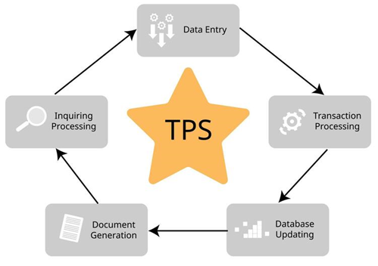

Scientific material for week seven
Types of Management Information Systems

- Online Analytical Processing Systems (OLAP)
These systems represent a qualitative evolution of Transaction Processing Systems (TPS). While TPS focuses on recording routine daily data, OLAP addresses the shortcomings of TPS in meeting management's needs in the areas of:
- Data analysis and trend modeling.
- Indicator forecasting and providing value-added insights to managers.
- Understanding current and future conditions, particularly the organization's competitive position.

Technical Features and Capabilities
Real-time analytical processing systems possess several capabilities that make them a strategic management tool:
- Multidimensionality: They provide data with multiple dimensions and aspects that encompass all variables of the phenomenon under study.
- Speed ​​and Real-Time Compatibility: They have a high capacity for real-time information retrieval and immediate analysis of results.
- Methodology: They systematically analyze data stored in databases or data warehouses.
- Addressing the "Information Overload" Problem: They help combat the flood of detailed data that is otherwise meaningless, transforming it into insights that improve decision-making effectiveness.

Levels and Evolution of Analytical Processing Systems (Hierarchy)
These systems have evolved through several stages, as shown in the attached hierarchical diagram:
- Data Processing Systems (DPS): The basic level.
- Transaction Processing Systems (TPS): The operational level.
- Online Analytical Processing Systems (OLAP): The general analytical level.
- Relational OLAP: Systems that work in conjunction with relational database management systems.
- Intelligent OLAP: Systems that use artificial intelligence techniques to explore complex relationships between data.

System Structure (Server and Client)
The OLAP system is based on a Server/Client architecture:
- Server: Manages system resources and executes intelligent and sophisticated queries.
- Client: The end user (administrator) who asks questions and receives useful information reports electronically and in real time.
- Data Sources: The system draws its data from the organization's databases, external databases, and multidimensional databases.
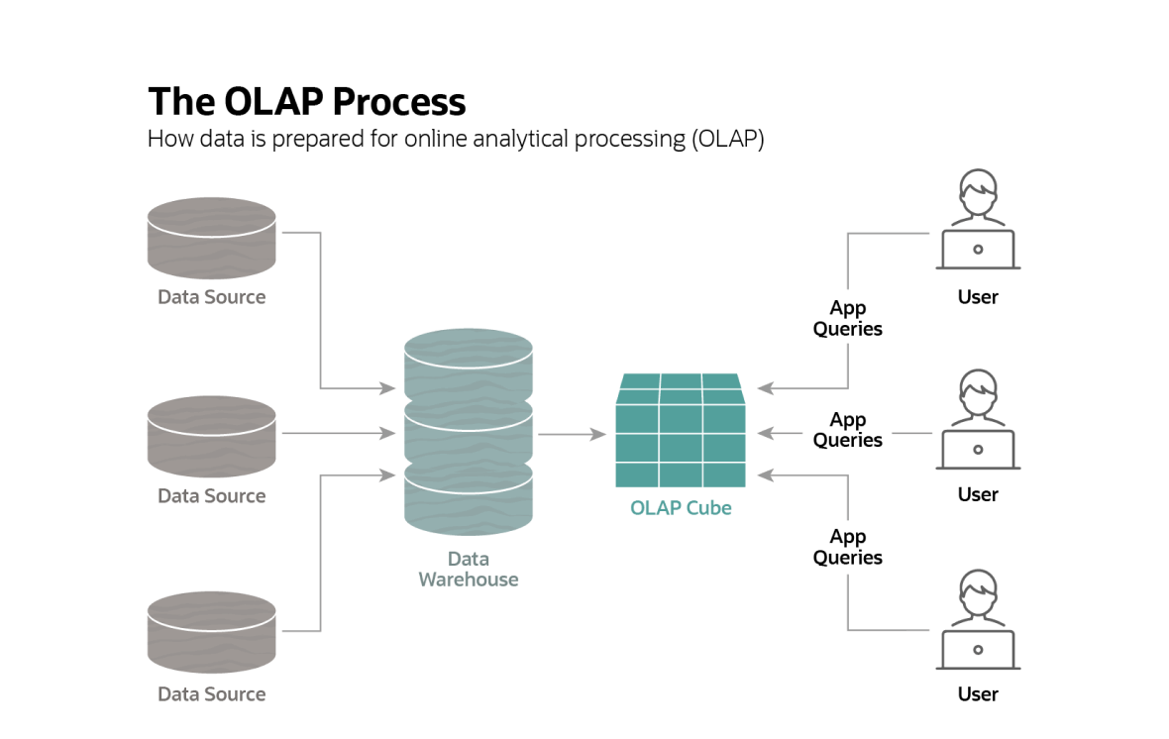

- Data Warehouse Systems
Data warehouses are defined as management information systems designed to ensure the integration of data resources from multiple, distributed sources. Their primary objectives are:
- To provide user-friendly interfaces and query tools.
- To facilitate immediate access to data.
- To enable users to retrieve information and generate reports to support decision-making.
Important Note: These systems are considered the "strong technical foundation" for all types of information systems that rely on immediate and flexible response, such as data mining systems and online analytical processing (OLAP) systems.

Dimensions of Data Warehouse Systems (IBM Model)
- Internal and External Data: These are the sources that feed the warehouse with information.
- Spreadsheets: For viewing and organizing digital data.
- Data Communications: The channels that ensure the flow of information.
- Data Visualization: Using visual aids to facilitate understanding of complex data.
- Reporting: The final outputs that managers need.
- Data Analysis and Decision Modeling: Transforming data into mathematical and logical models that help in selecting the best alternative.
- Queries: Tools that allow the user to search for specific information.
- Charts and Graphs: Illustratives that summarize the results.
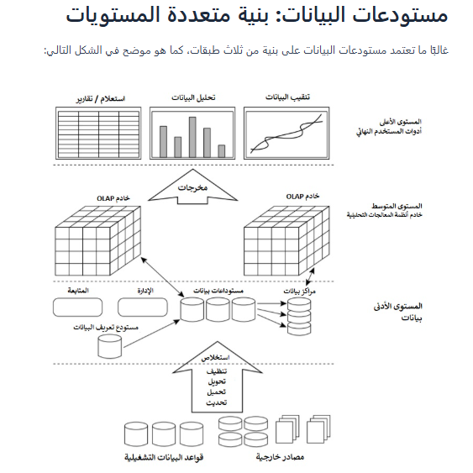

Scientific material for week eight
Types of Management Information Systems

- Data Mining Systems (DMS)
Data mining systems are the process of using sophisticated analytical tools to find hidden and stable patterns in large transaction databases. They aim to discover meaningful relationships between data elements that may not be immediately apparent within massive datasets.

These systems employ intelligent mining techniques that surpass traditional query languages ​​like SQL used in Access or Oracle software. They go beyond simply answering a direct query to uncover relationships that the user might not have anticipated.

Functions of Data Mining Systems
These systems are not limited to searching alone, but also include:
- Discovery and Research: Finding useful data and relationships.
- Connection Building: Creating new links and relationships that the organization can leverage.
- User Classification: Classifying customers, suppliers, and others based on their behavior.
- Inference: Finding inferential patterns by examining records in database files or data warehouses.

Mining Techniques and Tools
The data warehouse engine connects to four main tools that act as analytical tools for testing solutions and uncovering patterns:
- Query and Reporting Tools: For the systematic retrieval of information.
- Intelligent Agent: Software that automates information retrieval.
- Multidimensional Analysis Tools: For analyzing data from different perspectives.
- Statistical Tools: For applying mathematical equations and discovering trends.
In short: Data mining is the process of transforming stored "raw data" into "strategic knowledge" that helps an organization understand its customers' behavior and predict future needs.

- Decision Support Systems (DSS)
A DSS is defined as a computerized, interactive system that assists decision-makers in addressing unstructured and semi-structured problems. It aims to support the decision-making process, not replace the decision-maker, particularly in strategic (senior) and tactical (middle) management.

Key Components
- Database Management System (DBMS): Responsible for storing, processing, and retrieving data relevant to decision-making.
- Model Management System (MBMS): Includes a suite of software models (strategic, tactical, and operational) for analyzing various management problems.
- Interface/Dialogue Subsystem: The interface that connects the user to the system, featuring a user-friendly interface and interactive graphics tools.

- Group Decision Support Systems (GDSS)
A GDSS is an advanced generation of decision support systems that integrates computer technologies and technical support tools for teamwork. It aims to create synergy between groupware and decision support technologies. Its primary function is to facilitate the resolution of unstructured and semi-structured problems by providing an interactive environment that supports the "collective mind" of decision-makers.

System Subcomponents
A GDSS system consists of four main elements:
- Database: A large-capacity, relational, and distributed database.
- Software Package (Models): Includes statistical, mathematical, financial, and accounting models managed through an MBMS.
- Communication Support Software: For coordinating and exchanging knowledge and information among team members.
- Interactive Interface: Allows users to send and receive inquiries, ask questions, and review viewpoints in real time.

Additional Supporting Tools and Software
The system provides a range of tools that enhance the mental and organizational processes, including:
- Electronic Brainstorming: For gathering non-routine ideas and feedback.
- Idea Generation: Software for generating innovative solutions.
- Voting Support: For choosing between available solutions.
- Negotiation Support System: Very useful when members have differing viewpoints on goals or courses of action.
- Organizational Tools: Such as the Group Outliner and the Group Dictionary.

- Executive Information Systems (EIS)
These systems are also known as "strategic information systems." They are advanced, interactive systems that combine the advantages of Management Information Systems (MIS) and Decision Support Systems (DSS). They aim to support senior management in "strategic management" by analyzing internal strengths and weaknesses and identifying external opportunities and threats. These systems are linked to the field of artificial intelligence to provide managers with a clear and comprehensive view from multiple dimensions.

Characteristics of Executive Information Systems
- Intense competition: which has become global and interconnected.
- Rapid environmental change: which has complicated the decision-making process.
- The need for differentiation: The ability of these systems to fundamentally change the way work is done gives the organization a competitive advantage.

Features and Capabilities of EIS Systems
These systems possess essential characteristics that make them unique, the most important of which are:
- Drilling Down: This allows managers to start with general strategic reports and then delve into the specifics of the information as needed.
- Key Performance Indicators (KPIs): These provide information on the organization's core success factors and strategic performance indicators.
- Supporting Non-Structural Decisions: Providing the information necessary for making non-routine and unpredictable decisions.
- Structural Integration: Linking the strategic vision, objectives, implementation plans, and available resources to achieve synergy across the organization's activities.
(These systems are the "dashboard" that leaders use to see the big picture of the organization and its details simultaneously, helping them chart the company's future based on accurate data and intelligent analytics.)

Scientific material for week nine
Management Information Systems and Artificial Intelligence

- Intelligence (according to Webster's Dictionary):
is the ability to understand new circumstances or situations, and the ability to learn and reason. In short, its keys are: perception, understanding, and learning.
- Artificial Intelligence (AI):
is making machines (computers) mimic human intelligence. It is the science concerned with designing intelligent computer systems that mimic human behavior in thinking and acting.
- The AI ​​Family
The table shows that artificial intelligence is not a single technology, but rather a "family" that branches into four main areas:

Examples and Applications | Domain
Natural Languages, Speech Recognition, and Virtual Reality (VR). | Interface & Environmental Applications
Robotics (Visual Perception, Locomotion, and Navigation). | Intelligent Machine Applications
Language Processing, Neural Networks, and Fifth-Generation Computing. | Computer Science Applications
Expert Systems and Fuzzy Logic. | Cognitive Science Applications

- Characteristics and Features of Artificial Intelligence
- Reasoning and Perception: The capacity for advanced analytical processing.
- Problem Solving: Utilizing intelligence to derive logical outcomes and solutions.
- Learning from Experience: Enhancing performance and avoiding repetitive errors through iterative learning.
- Knowledge Acquisition: The ability to gather, process, and effectively apply information.
- Creativity and Imagination: Providing innovative and non-conventional solutions.
- Handling Complex Scenarios: The capability to analyze intricate and interconnected variables.
- Rapid Response: High-speed reactivity and adaptation to new or changing circumstances.
- Prioritization (Determining Significance): Identifying the most critical elements within a given context.
- Dealing with Ambiguity: The ability to make decisions even when data is incomplete or uncertain.
- Managerial Decision Support: This represents the primary objective within the context of "Management Information Systems (MIS)."

- Expert Systems (ES)
An Expert System is a knowledge-based information system designed to act as an "Expert Consultant" for the end-user. It models the human expert's ability to solve complex problems and provides rapid solutions that enhance organizational stability. It is considered one of the most widely utilized patterns of Artificial Intelligence in the business domain.

- Benefits of Expert Systems for Management
These systems provide significant strategic advantages, including:
- Knowledge Preservation: Storing both explicit and tacit knowledge and documenting human expertise for long-term use.
- Objectivity and Neutrality: Ensuring rational decision-making that is free from emotions, biases, or psychological inclinations.
- Temporal and Spatial Efficiency: Providing the flexibility to utilize the system at any time and in any location.
- Decision Support: Offering critical support to managers and automating complex, routine tasks through advanced computing.

- The Architecture of Expert Systems (Core Components)
The system consists of several structural units, which are:
- Knowledge Base: It contains the specialized knowledge extracted by the Knowledge Engineer from human experts.
- Working Memory: It contains the specific facts related to the current problem being investigated.
- Inference Engine: This is the "Processor" that combines facts from the working memory with the rules in the knowledge base to derive solutions.
- Explanation Facilities: The system's ability to explain to the user "Why" and how it reached a specific conclusion.
- User Interface: The medium that facilitates the dialogue between the user and the system, often based on Natural Language.

- System Development Requirements (The Working Team)
The development of an Expert System requires collaboration among three primary stakeholders:
- Domain Expert: The individual who possesses deep expertise, extensive knowledge, and specialized problem-solving skills in a specific field.
- Knowledge Engineer: The analyst and designer responsible for extracting knowledge from the human expert and formalizing it into a programmable format within the system.
- End-User: The individual who ultimately operates the system; the system's success depends on its usability and the user's acceptance of it.

- Genetic Algorithms Systems (GAS)
Genetic Algorithms are based on simulating the evolutionary processes that occur in nature. Simply put, they are computer programs that mimic the logic of "Survival of the Fittest" to find solutions to complex problems.
Inspired by Darwinian concepts of "Natural Selection," these systems aim to identify the "Optimal Solution" among thousands or millions of possibilities that are difficult for humans or traditional programs to evaluate individually.

Mechanism of Genetic Algorithm Systems (GAS)
These algorithms operate based on three primary biological concepts:
- Crossover (Genetic Combination): Merging characteristics from two different candidate solutions to produce a "new generation" of solutions that may outperform their predecessors.
- Mutation: Introducing minor random changes into the solutions to explore new paths and prevent the system from getting trapped in a loop of suboptimal, similar solutions (Local Optima).
- Natural Selection: Eliminating weak solutions and retaining the strong (most efficient) ones to continue the evolutionary process.

The program commences with a population of stochastic (random) solutions, which then "compete" and evolve through successive generations. The solution that demonstrates the highest efficiency is the one that "survives" and is ultimately adopted.

- Application Domains of Genetic Algorithms
Today, Genetic Algorithms are utilized in critical and complex domains, including:
- Business and Finance: Portfolio management and risk assessment.
- Logistics: Identifying optimal shipping routes, inventory control, and material flow management.
- Advanced Sciences: Genetic Engineering.
- Aerospace Engineering and Manufacturing.
- Nanotechnology and Biomaterials Industry.
Scientific material for week ten
Systems Analysis and Design (SAD)

- Concept of Systems Analysis and Design
Systems Analysis:
It is the process of decomposing the current system into smaller components to understand how they function and the role of each part within the overall system. This phase aims to identify the strengths and weaknesses of the existing system and to define the Information Gap—, which is the discrepancy between what the system currently provides and what the users actually require.

Systems Design:
This phase immediately follows the analysis and relies heavily on its outputs. It aims to transform the Logical Design of the system (specifications and requirements) into practical models, operational programs, and executable procedural steps.

- The Systems Analyst
The Systems Analyst is the individual responsible for planning and executing the systems analysis and design process. This role may be fulfilled by a single person or a team. The analyst is characterized by the ability to integrate analytical, technical, and interpersonal skills.

Tasks and Responsibilities of the Systems Analyst
The Systems Analyst exerts significant effort across several vital dimensions:
- Problem Analysis: Conducting an in-depth study of the problem to comprehend its root causes.
- Requirements Determination: Identifying what the users actually require from the information system.
- Solution Specification: Proposing appropriate technical and procedural solutions for the identified problems.
- Conflict Resolution: Resolving disputes and contradictions that may arise among stakeholders and system users to ensure organizational consensus.

Skills of the Systems Analyst
- Science and Technology: The proficiency in utilizing modern tools, methodologies, and advanced technologies.
- Creativity and Art: Innovation in generating solutions; systems analysis is as much a creative "art" as it is a technical science.
- Practical Experience: Academic qualifications alone are insufficient. An analyst requires years of accumulated experience and hands-on practice to design a successful and effective system.

- Systems Development Life Cycle (SDLC)
The traditional methodology follows the Waterfall Model, where each phase delivers its outputs to serve as inputs for the subsequent phase. It typically consists of five fundamental stages:
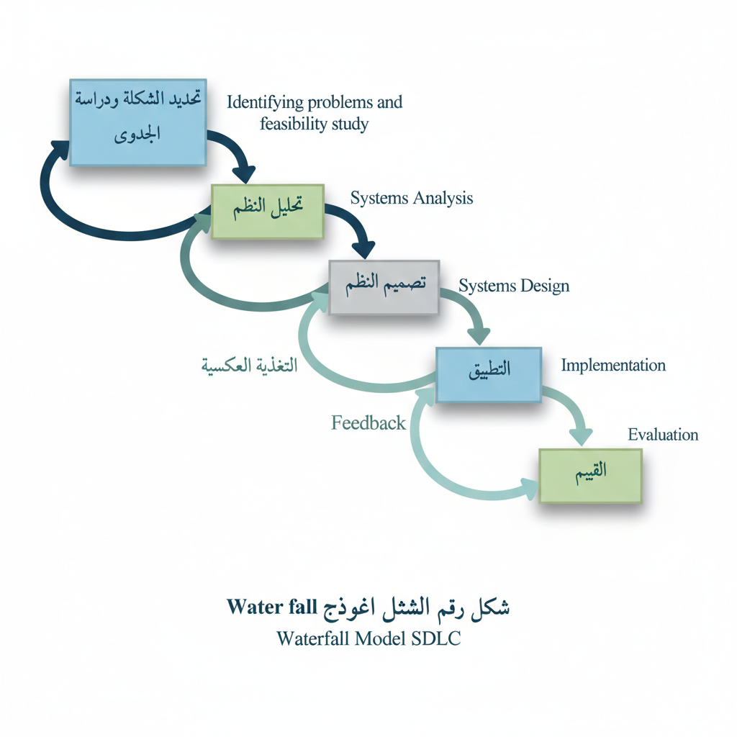

Stages of the Systems Development Life Cycle (SDLC)
- Problem Identification and Feasibility Study
- Problem Identification: Verifying the actual need for system development (e.g., decline in productivity or loss of competitive advantage).
- Feasibility Dimensions: Includes Economic Feasibility (Cost-Benefit Analysis), Technical Feasibility (Availability of technology), and Organizational Feasibility (Alignment with organizational goals).

- Systems Analysis
- Aims to understand stakeholders' needs and define the objectives and constraints of the new system.
- Includes specifying Outputs, Processes, Inputs, and the necessary resources for system operation.

- Systems Design
- Logical Design: Creating abstract conceptualizations of system specifications and functions prior to physical implementation.
- Physical Design: Defining input media, process algorithms, and specifications for Hardware and Software.

- Implementation Phase
This stage involves programming, user training, and hardware installation. It also includes System Conversion Strategies:
- Direct Cutover (Plunge): Abruptly stopping the old system and starting the new one.
- Parallel Running: Operating both systems simultaneously for a period to ensure accuracy.
- Phased Conversion (Gradual): Replacing parts of the old system with the new one incrementally.

- Evaluation Phase
Conducted after system deployment to measure its success in achieving objectives.
- Direct Evaluation (Short-term): Comparing actual costs (Hardware, Software) against Tangible Benefits (Increased productivity, cost reduction).
- Intangible Benefits (Long-term): Such as improved decision-making, gaining a Competitive Advantage, and fostering a culture of leadership and innovation.

- Utilizing Prototyping in Information Systems Development
The Concept of Prototyping:
Prototyping is the process of building an initial, preliminary version of the final information system. The primary objective of this methodology is to ensure the active involvement of stakeholders (users) throughout the development process. This approach avoids the pitfalls of traditional methodologies, which often spend extensive time in analysis without seeking continuous user feedback.

Rationale for Prototyping (Why Use It?)
Prototyping is utilized to address several challenges inherent in traditional approaches, most notably:
- Difficulty in Defining Requirements: The challenge systems analysts face in accurately identifying the precise needs of stakeholders.
- Inadequacy of Traditional Documentation: The inability of "narrative descriptions" or "Data Flow Diagrams (DFDs)" to effectively represent the dynamic nature of the system.
- Addressing Communication Barriers: Managing complex human factors and communication gaps that arise when development teams are large and possess diverse areas of expertise.
- Time and Cost Constraints: Overcoming the excessive time requirements and prohibitive costs often associated with traditional development methodologies.

Stages of the Prototyping Process (The Spiral Process)
Prototyping follows an iterative cycle of steps until user satisfaction is achieved:
- Identification of Core Requirements: Determining the essential needs and functionalities required by the user.
- Development of the Initial Prototype: Building a rapid version of the system using CASE tools (Computer-Aided Software Engineering) or Fourth-Generation Languages (4GLs).
- Prototype Implementation: Deploying the initial version for hands-on testing and usage by the stakeholders.
- Review and Refinement: Documenting user feedback, reassessing the model, and iterating the process until full satisfaction is reached, followed by the final approval and adoption of the system.

Scientific material for week eleven

- Management Information System Development Techniques through Application Software Package.
These packages are ready-made programs designed in advance by specialized companies, and using them saves a lot of effort and time compared to building a system from scratch.

Key Advantages
- Time Efficiency: Significantly reduces the time required for analysis, design, and programming.
- Cost Reduction: Lowers the overall development costs of Management Information Systems (MIS).
- Quality and Reliability: Often delivers high technical quality and well-tested performance.

Disadvantages and Challenges
- Lack of Comprehensiveness: The software package may not cover all the specific functions required by the organization.
- Complexity of Customization: Making programmatic adjustments (Customization) can be technically challenging, financially expensive, and time-consuming.
- Diminishing Returns: Excessive modification may lead to losing the original advantages and core benefits of the software package.

Selection Criteria and Software Package Evaluation
When considering the purchase of a software package, a set of criteria must be employed for comparison, primarily:
- Functionality Criterion
This criterion focuses on the extent to which the software can perform the required tasks.
- Core Capabilities: What specific functions does the program execute?
- Scalability: Can the software be developed or expanded in the future?
- Customization Costs: What are the costs associated with making necessary modifications?
- Flexibility Criterion
This criterion measures the software's capacity to adapt to organizational changes without requiring a complete code rewrite.
- Modifiability: To what extent can the software be adjusted or reconfigured?
- Business Scope: Does it cover a wide range of diverse business activities?
- Interoperability & Integration: Can the system interact and integrate seamlessly with other applications?
- User-Friendliness Criterion
This criterion evaluates the ease of use for employees who are not programming specialists or technical experts.
- Interface Intuition: Is the user interface (UI) simple, direct, and easy to navigate?
- Guidance and Error Alerts: Does the software provide instructional messages and real-time notifications when errors occur?
- Documentation and Help Tools: Are there clear, comprehensive, and detailed "Help" resources available to the user?
- Cost-Benefit Analysis Criterion
This involves comparing the projected benefits—both tangible and intangible—against the total costs of the system.
- Value Addition: The value added by the system must exceed its total cost of ownership.
- Competitive Advantage: The relationship between the system and the organization’s competitive advantage must be thoroughly analyzed.

- Hardware and Software Compatibility Criterion
This criterion ensures that the new software is fully compatible with the existing hardware and systems within the organization.
- Operating System Alignment: Is the software compatible with the current Operating System (OS)?
- Infrastructure Upgrades: Does the existing hardware (computers, servers, and networks) require upgrades or enhancements to run the software effectively?
- Incremental Hardware Costs: What are the additional costs associated with upgrading the hardware infrastructure.

- Techniques for Developing Management Information Systems (MIS)
A variety of tools and techniques are employed in the systems analysis and design process to describe internal logic and operational processes:
2.1. Data Flow Diagrams (DFD):
2.2. Entity-Relationship Diagrams (ERD):
2.3. Structured English
2.4. Decision Tables
2.5. Decision Trees

  - Data Flow Diagrams (DFD)
DFDs are considered one of the most effective techniques for modeling system processes graphically and visually, rather than using narrative text.

Key Advantages:
- Process Modeling: Modeling system processes and providing a foundational baseline for technical and programmatic implementation.
- Structural Understanding: Providing a deeper understanding of the complex interrelationships between the system and its subsystems.
- Integrity Checking: Helping to determine whether all necessary processes and data have been defined and thoroughly analyzed.

Basic Symbols Used:
These diagrams rely on four standard symbols:
- Entity (External Entity): Represents external sources or destinations (e.g., a Student).
- Data Flow: Represents the movement and direction of data within the system.
- Process: Represents the activities or transformations performed on the data.
- Data Store: Represents the location where data is retained for later use.

Stages of Constructing Data Flow Diagrams (DFDs)
The process requires a holistic view of the system, proceeding from the top-down according to the following steps:
- Compiling a List of Processes and Activities: Identifying the core components, as well as the internal and external entities.
- Creating the Context Diagram: Illustrating the entities associated with the system and the primary data flows without delving into details.
- Drawing the Level-0 Diagram: Highlighting the major processes and data storage areas.
- Drawing the Level-1 Diagram (Child Diagram): Providing a detailed breakdown of each process identified in the Level-0 diagram.
- Verification and Auditing: Ensuring the absence of errors and confirming that all processes and flows have clear, descriptive names.
- Developing the Physical DFD: Distinguishing between computerized and manual processes, and describing actual files and reports.
- Refinement and Simplification: To streamline the subsequent programming and implementation phases.

  - Entity-Relationship Diagrams (ERD)
ERDs are used for database modeling and representing business data. They consist of three fundamental elements:
- Entities: Anything (person, place, event, or concept) that has an independent existence, such as: "Employee", "Customer", or "Product".
- Attributes: The characteristics or properties that describe an entity, such as a student's "University ID". These attributes are later converted into table fields, with one designated as the Primary Key.
- Relationships: These link entities together and are classified into several types:
- One-to-One (1:1)
- One-to-Many (1:M)
- Many-to-Many (M:N)

Scientific material for week twelve
Database system

- Database Management Systems (DBMS)
The Concept of Database and its Components
Database: A logical, organized collection of interrelated data, representing an integrated arrangement of business files. It consists of the following sequential hierarchy:
- Character: The smallest logical element, consisting of a single letter, symbol, or number (comprising 8 bits / 1 Byte).
- Field: A collection of characters representing an Attribute that describes a specific entity, such as "Student Name" or "University ID."
- Record: A collection of related fields within a table. A single record represents a complete instance (e.g., all data pertaining to one student). Each record is uniquely identified by a Primary Key, which cannot be duplicated.
- File (Table): A collection of integrated and related records. In Relational Databases, a file consists of tables organized into columns (Fields) and rows (Records).

Database Management System (DBMS)
The DBMS is the software responsible for managing and executing activities related to the creation, storage, processing, retrieval, and updating of data to meet user requirements. It consists of the following core components:
- Data Definition Language (DDL): Used to define database structures, including tables, fields, and data types.
- Data Manipulation Language (DML): Used for querying, updating, inserting, and deleting data.
- Data Control Language (DCL): Responsible for protecting database resources and managing user permissions and access control.
- Database Engine: The core service and processor technically responsible for executing all database activities and operations.
- Tools and Utilities: Includes user interfaces and developer tools used to build and integrate new query functionalities.
- Data Dictionary: It contains "Metadata", which is defined as "data about data." It provides a comprehensive description of the characteristics, constraints, and data types associated with the entities within the system.

Benefits of Database Management Systems (DBMS)
The system provides several strategic advantages to organizations, including:
- Eliminating Redundancy and Duplication: This reduces the costs associated with maintaining and storing data resources.
- Speed and Accuracy: It provides Real-time connectivity and data access for users.
- Functional Integration: It achieves seamless integration among all subsystems within the Management Information System (MIS).
- Decision Support: It ensures a reliable data foundation for the management system, as the database is considered the "Beating Heart" of the entire system.

- Database Structures
There are five primary patterns for organizing and managing databases:
- Hierarchical Structure
- Description: Resembles an Inverted Tree, where data begins at the top (The Root) and branches out downwards.
- Relationship Type: Primarily supports One-to-Many (1:M) relationships.
- Historical Context: Historically associated with early Mainframe computing systems.
- Disadvantages: High difficulty in performing changes or modifications, and a lack of support for Ad-hoc (unstructured) queries.

- Network Structure
- Description: Consists of interconnected chains of data that represent more complex logical relationships.
- Relationship Type: Supports Many-to-Many (M:N) relationships.
- Key Advantage: It allows users to access information through multiple paths or entry points.

- Relational Structure
- Description: The most widely used and prevalent model today. Data is stored in tables (referred to as Relations).
- Components: Columns: Represent the Fields.
- Rows: Represent the Records (Tuples).
- Linking: Tables are linked using Primary Keys and Foreign Keys.

- Object-Oriented Structure (O-O)
- Description: A result of integrating the relational structure with Object-Oriented Programming (OOP) technology.
- Key Features: It stores not only the data itself but also the Behavior and operations associated with that data.
- Core Concepts: Based on Objects, Classes, Inheritance, and Encapsulation.

- Multidimensional Structure
- Description: A model derived from the relational structure, used to organize and classify data across multiple dimensions.
- Visualization: Data is represented in the form of Data Cubes.
- Usage: Highly effective in Data Warehousing, Data Mining, and Online Analytical Processing (OLAP).

Scientific material for the thirteenth week
Databases

- Database Development
This process is a fundamental and vital part of the Systems Development Life Cycle (SDLC) and consists of several key stages:
- Planning and Analysis: The process begins by planning and analyzing the needs of the business and its stakeholders, based on a thorough analysis of the current system.
- Logical Design: Establishing a logical framework that illustrates how the data will be organized (independent of any specific software).
- Physical Design: Translating the logical design into a technical reality by selecting the appropriate Database Management System (DBMS), such as Oracle, SQL Server, or Microsoft Access.
- Implementation and Evaluation: Deploying the system in a real-world environment and measuring its efficiency and performance at every stage.

Core Activities in Database Development
The Systems Analyst and Designer (or the Database Development Team) undertake a series of technical tasks to ensure system accuracy:
- Process Modeling: Characterizing the activities performed by the system using tools such as Data Flow Diagrams (DFD).
- Data Modeling: Constructing relationships between various entities (data elements) using Entity-Relationship Diagrams (ERD).
- Normalization: A systematic process aimed at organizing data and minimizing redundancy to ensure logical and sound data integrity.

- Data Normalization
Normalization is the process of transforming complex and disorganized user views into a simple, robust, and interrelated data structure to minimize redundancy. This is achieved through three fundamental levels:
- First Normal Form (1NF)
Objective: To Remove Repeating Groups.
Description: If a table contains more than one independent entity, it must be decomposed into two or more separate tables to represent each entity individually.

- Second Normal Form (2NF)
Objective: To Remove Partial Dependencies.
Description: This ensures that all non-key fields are fully and directly dependent on the Primary Key. No field should depend on only a part of a composite primary key.

- Third Normal Form (3NF)
Objective: To Remove Transitive Dependencies.
Description: It requires that non-key fields do not depend on each other; they must depend exclusively on the Primary Key.

Scientific material for week fourteen
Management Information Systems (MIS) and E-Business Activities

E-Business cannot succeed without a sophisticated database, developed through rigorous stages (Planning, Analysis, Logical and Physical Design). Furthermore, the Normalization process is employed to ensure that data is organized into simple, interrelated tables, facilitating the highly efficient retrieval of customer and supplier information.

- Network Infrastructure (The Technical Foundation)
E-business relies on three distinct network levels to ensure effective and secure communication:
- Intranet: The organization's internal network designed for employees. It provides software resources, multimedia databases, and Document Management Systems (DMS) to support internal coordination and operational execution.
- Extranet: Acts as a bridge connecting the organization with its Business Partners and suppliers. It is used to exchange supply chain data, procurement information, and payments with complete confidentiality.
- Internet: The public-facing interface that connects the organization with its Customers. It enables them to browse products and services, navigate and search, place purchase orders, and utilize instant payment services.

- Core Activities and Operations
The E-Business model is built upon a set of integrated activities:
- Content and Website Management: Utilizing the necessary tools and software to manage the electronic website content through which all business activities are conducted.
- Resource Protection Services: Providing comprehensive security for processing marketing transactions and safeguarding stakeholder and user data.
- Electronic Data Interchange (EDI): Adopting advanced systems for information and data exchange between the organization and its partners to ensure confidentiality and speed.
- Decision Support: Relying on Data Warehouses, Decision Support Systems (DSS), and customer account databases to accurately guide operations.

- Information Security in E-Business
Due to the openness of these systems to external networks, sophisticated protection technologies are employed:
- Firewalls: Act as a protective barrier at internet connection nodes to prevent unauthorized access.
- Encryption: Used to protect business messages and ensure the confidentiality of transmitted data.
- Authentication: Ensures that only authorized users (whether customers, partners, or employees) have access to tools and software.

- Requirements for Implementing E-Business Systems
Implementing E-Business systems requires a comprehensive strategy and an integrated architectural design. The core requirements include:
- Strategy and Architecture
- Strategic Formulation: Implementation necessitates formulating and applying a comprehensive business strategy, followed by a specific strategy for the development and deployment of E-Business systems.
- Architectural Foundation: The system architecture must be built on an engineering basis that defines core business domains and their pivotal areas.
- Process Packaging: Grouping core activities into Streamlined Process Bundles that are executed in real-time via the internet.

- Network Infrastructure (Strategic Synergy)
- System Synergy: Success cannot be achieved without a functional synergy between Information Technology systems and networks.
- Triple-Network Integration: Reliance on the integration of three primary networks: Intranet (for internal operations), Extranet (for dealing with partners and suppliers), and the Internet (for customer outreach).
- Digital Space: Utilizing the Internet as an open digital space to develop and implement Network-Centric Management Information Systems.

- Human Resources and Technical Expertise
- Knowledge Workers: The necessity of a workforce consisting of high-level Knowledge Workers with advanced skills and expertise.
- Capital Activation: Activating Intellectual, Human, and Organizational Capital to ensure the success of the business strategy.

- Integration of Traditional and Electronic Activities
- Synergy: E-Business systems are not an absolute replacement for traditional business; rather, they must be integrated.
- Modernization: Working on "vaccinating" rigid traditional frameworks with the "E-Business vaccine" to evolve and develop the organization's systems.

- Organizational and Operational Requirements (Activity Bundles)
According to the modern architectural blueprint for E-Business, six essential bundles must be present:
- Enterprise Resource Planning (ERP): To achieve functional integration within the organization.
- Supply Chain Management (SCM): To link the organization with suppliers and ensure the flow of products and services.
- Customer Relationship Management (CRM): To connect marketing and sales systems with customer needs.
- Decision Support Systems (DSS): To provide the necessary information for management.
- Application Development and Content Management Tools: To manage the website and the provided services.
- Financial Services and Supply Chains: To ensure the flow of funds and financial operations.

