Personal Details
Name | Noura Bouchta Mohammed Danedoun |  |  |  |  |  |  |  |  |  |  | 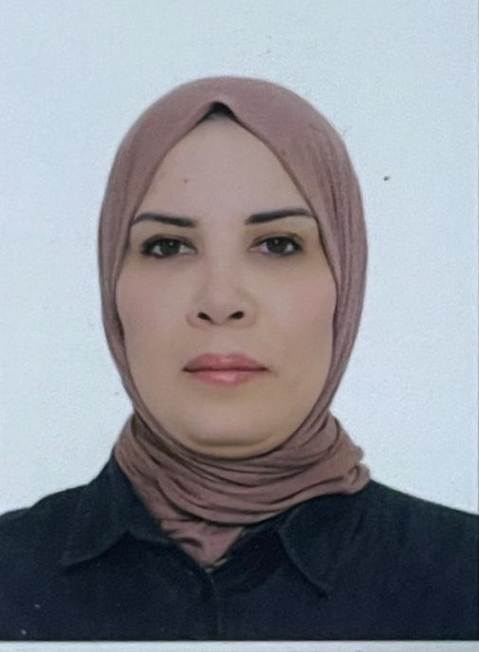
Email | Noura@gmail.com
Phone Number | 07729094000
Address | Kout lhoujaj tahssiniya
Education
Certificate |  | Date |  |  | University |  |  |  | Country
Master |  | 2007 |  |  | Sidi Mohammed Ben Abdullah |  |  |  | Morocco
Languages
 |  | Arabic
 |  | French
Training Courses/ Workshops
Title |  |  |  | Date |  |  |  |  |  |  | Period |  |  | Country
Teaching Experience
Title |  |  |  |  |  |  | From |  |  |  |  |  | To
University teaching |  |  |  |  |  |  |  | 2013 |  |  |  |  | 2024
Scientific Research
Title |  |  |  |  |  |  |  |  |  | Place & Date of Publication
Awards and Certificate of Appreciation
Certificate |  |  | Date |  |  | Issued by
Teaching Experience
Subject |  |  |  |  |  |  |  |  |  | Stage
The French language ( skills ,basics and grammar ) |  |  |  |  |  |  |  |  |  | All educational levels

