Personal Details
Name | Mohammed Alaa Hussein |  |  |  |  |  |  |  |  | 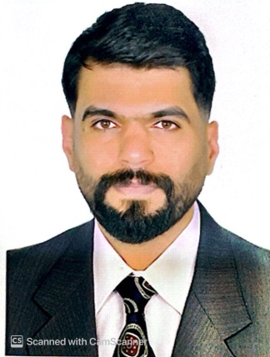
Email | Mohammedala1993@gmail.com muhamad.alaa@sa-uc.edu.iq
Phone Number | 07829056657
Address | Al-Muharbeen District
Education
Certificate |  | Date |  |  | University |  | Country
M.A |  | 15-1-2024 |  |  | Islamic Azad University |  | Iran
Languages
English
Arabic
Training Courses/ Workshops
Title |  |  |  | Date |  |  |  |  | Period |  | Country
Scientific Research
Title |  |  |  |  |  |  |  | Place & Date of Publication
Awards and Certificate of Appreciation
Certificate |  |  | Date |  |  | Issued by
Certificate of Appreciation |  |  |  |  |  | Shatt Alarab University
Teaching Experience
Subject |  |  |  |  |  |  |  | Stage
Reading |  |  |  |  |  |  |  | Second
Essay |  |  |  |  |  |  |  | Third

