personal information
Taif Yaseen Taha  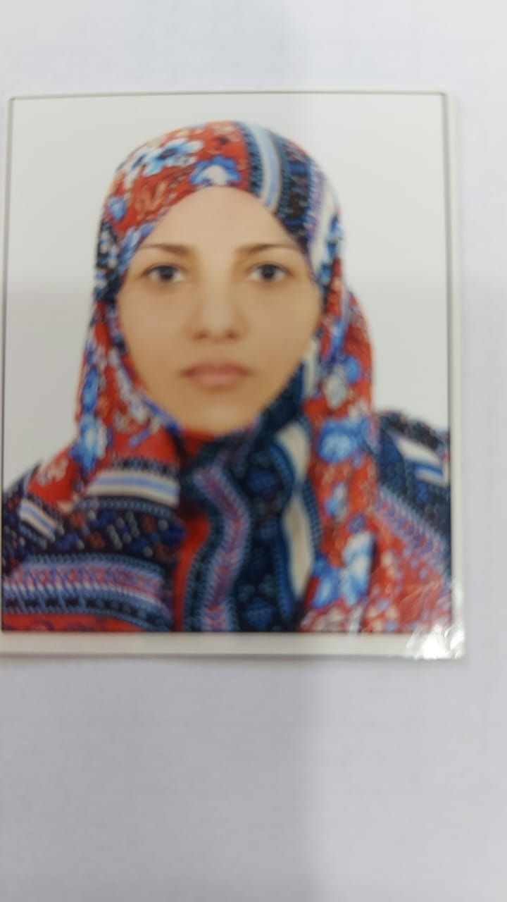 |  |  |  | Name
Basrah – 12/ 4/1975 |  |  |  | P&D.OB:
Iraqi |  |  |  | Nationality
Married |  |  |  | Marital Status
taif20100@yahoo.com |  |  |  | E-mail
07712668274 |  |  |  | the phone
Legal Accounting |  |  |  | Certificate
Assistant teacher |  |  |  | The scientific title
9/9/2024 |  |  |  | Date of appointment to the college
Legal Accounting |  |  |  | general jurisdiction
Accounting & Auditing |  |  |  | exact jurisdiction
Legal Accounting |  |  |  | current jurisdiction
Certificates and academic titles
Country | the University | Academic thesis title | its history | Certificate
Iraq | Arab Institute of Certified Public Accoutant (AICPA) | The impact of accounting and auditing standards on the quality of auditor performance | 7/10/2018 | Legal Accounting
The skills
Use of computer programs Word-Excel-PowerPoint |  |  |  | skills
very good |  |  |  | the Arabic language
Medium |  |  |  | English language
There is no other language |  |  |  | other language
training courses
management positions
From 2000 – 2012 Free Zone in Khor AL Zubair |  |  |  |  | Account Manager
From 2013 – 2023 Basrah Palm Trees Residential Project |  |  |  |  | Account Manager
research activity

cultural activities
place and time |  |  | Activity name
Awards, letters of thanks and appreciation certificates for the academic years
Study experiences
Educational level |  | The name of the subject you studied
The second stage / accounting department |  | Accounting applications
The Fourth stage / accounting department |  | International Accounting
the committees

