Personal Information

Full Name and Title |  |  | Ali Mahmoud Shaker Al Shaheen |  |  | 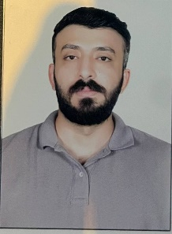
Date of Birth |  |  | 1996/9/21
Place of Birth |  |  | Basra
Nationality |  |  | IRAQI
Marital Status |  |  | Single
Number of Children
Address |  |  | Basra - Al-Muhandisin District
Email |  |  | ali.mahmud.shaker@sa-uc.edu.iq
Phone |  |  | 07860854987
Academic Title |  |  | Assistant Lecturer
General Specialization |  |  | Computer Science
Specific Specialization |  |  | Artificial Intelligence
Current Specialization |  |  | Networks

Degrees and Academic Titles
Degree | Date of Degree |  |  | Thesis/Dissertation Title | University |  | Country
PHD
Master’s Degree | 2022/5/18 |  |  | American Sign Language Recognition using YOLOv4 Method | Altinbas university

Skills
Skills
Arabic Language |  | 100%
English Language |  | 90%
Other Languages

Research Activity

Cultural Activities (Participation in Conferences, Seminars, etc.)
Activity Name | Location and Date
Cyber security | University of Basra, College of Medicine, Al-Zahraa

Awards, Acknowledgments, and Certificates of Appreciation for the Academic Year
Reason for Award | Issuing Authority | Date | Certificate

Teaching Experience
Academic Level | Courses Taught
Third stage | Computer network
Number of Theses/Dissertations Supervised | Supervision of Graduate Studies

