Personal Details
Name | Kasim Abdul Jabar Abdul Razak Alsalem |  |  |  |  |  |  |  |  | 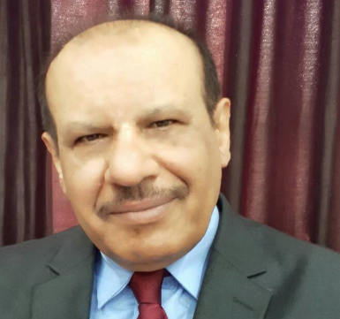  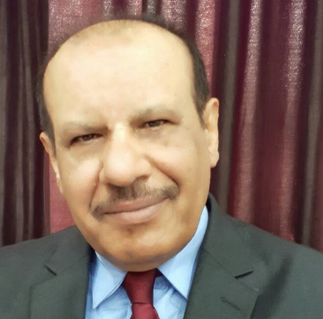
Email | Qasim.AbdulJabbar@sa-uc.edu.iq
Phone Number | 07700592170
Address | Basrah - Almhundseem
Education
Certificate | Date |  |  |  | University |  |  |  | Country
M.Sc. | 1983 |  |  |  | Dundee |  |  |  | UK
B.Sc. | 1977 |  |  |  | Basrah |  |  |  | Iraq
Languages
English | good
Arabic | Native
Other
Training Courses/ Workshops
Title |  |  | Date |  |  | Period |  |  | Country
– Training course in language laboratory Sony Co. TOKYO |  |  | 1979 |  |  | month |  |  | JAPAN
International Visitor |  |  | 1990 – |  |  | month |  |  | USA
Training course in Higher management & planning Bagdad |  |  | 1994- |  |  | month |  |  | IRAQ
Training course in logical Programming & control System University of |  |  | 1996- |  |  | Two weeks |  |  | SYRIA
Joined Work shop in Building Syllabus for Electrical & Electronic |  |  | 2000- |  |  | Two weeks |  |  | Amman , JORDAN
Managerial Position
Title |  |  |  |  |  | From |  |  | To
Head of Computer Technologies Engineering department Shatt Aiarab University |  |  |  |  |  | DEC 2024 |  |  | now
Assistant Dean For Administrative Affairs- Al KUNOOZE University college |  |  |  |  |  | 2023 |  |  | 2024
Head of the Medical Instrumentation Technologies Engineering department Al KUNOOZE University college |  |  |  |  |  | 2021 |  |  | 2023
Asst. Prof At Al KUNOOZE University college |  |  |  |  |  | 2018 |  |  | 2021
Asst. Prof At CIHAN University |  |  |  |  |  | 2012 |  |  | 2017
Head of Electronic Engineering Department at university of Science and Technology Sana'a-YEMEN. |  |  |  |  |  | 2008 |  |  | 2011
Asst. Prof. In Electronic Engineering Department at university of Science and Technology Sana'a-YEMEN. |  |  |  |  |  | 2004 |  |  | 2007
-Dean of Technical Institute of Samawa – IRAQ |  |  |  |  |  | 2001 |  |  | 2003
Dean of Technical Institute of Basra – IRAQ |  |  |  |  |  | 1997 |  |  | 2001
Scientific Research
Title |  |  |  |  |  | Place & Date of Publication
Multi-criteria vertical handover by TOPSIS and fuzzy logic‏1-  MM Alkhawlani, KA Alsalem, AA Hussein‏ |  |  |  |  |  |  | Communications and Information Technology  (ICCIT), 2011 International ...‏
Channel Overlapping Between IMT-Advanced Users and Fixed Satellite Service‏2-  KA Alsalem‏  ...‏ |  |  |  |  |  |  | International Journal of Electrical, Electronics and Computers (EEC Journal
A Statistical Transformation Tool For Natural Semantics‏3-  KAAS Salwa M. Ali ,Mohammed W. Al-Neama‏ |  |  |  |  |  |  | International Journal of Applied Engineering Research 12 (10), 2555-2558
Awards and Certificate of Appreciation
Certificate |  |  |  | Date |  |  |  |  |  |  | Issued by
Teaching Experience
 | Stage

