Personal Information
Full name and surname | Muhammad Abdul redha Majeed Almusawi |  |  | 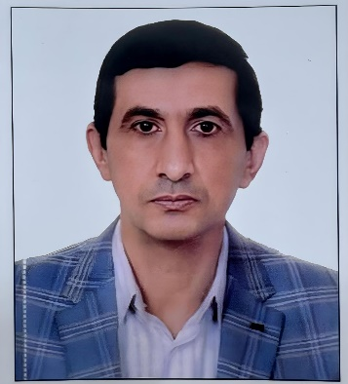
Birth | 13/12/1972
Generator shop | Basra
Nationality | Iraqi
Marital status | married
Number of children | 3
Address | Basra / Professors District / Four Streets
E-mail Address | Mohammed1972al@gmail.com
telephone | 13790310077
Scientific title | Assistant Lecturer
Certification | Master
Date of appointment in the college | 1/9/2024
General Jurisdiction | Accounting
Exact Jurisdiction | Financial Accounting & Corporate
Current Jurisdiction | Financial Accounting
Certificates and scientific titles
Certification | History |  | Thesis / Thesis Title | University | Country
Master | 25/4/2023 |  | The interactive role of board characteristics in the relationship between managers' overconfidence and social responsibility: testing stakeholder theory | Islamic Azad University | Iran
Skills
Skills
Arabic Language | Mother tongue
English Language | Good
Persian language | Good
Training Courses
There isn't any
Administrative Positions
There isn't any
Research activity
No

Cultural activities (participation in conferences, seminars, etc.)
No
Teaching Experience
Name of the course you studied |  | Name of the Institute
Intermediate Accounting / 1 |  | - Al-Amjad Institute for Remedial Courses  - Al-Awab Institute for Remedial Courses
Intermediate Accounting /2
Intermediate Accounting /
Accounting for financial establishments
E Management Accounting
Public Finance
Specialized Accounting
Cost Accounting
Commissions
There isn't any

