Biography and science
 | personal information
 | Assistant teacher, Wissam Nouri Abdel Hussein | Full name |  | 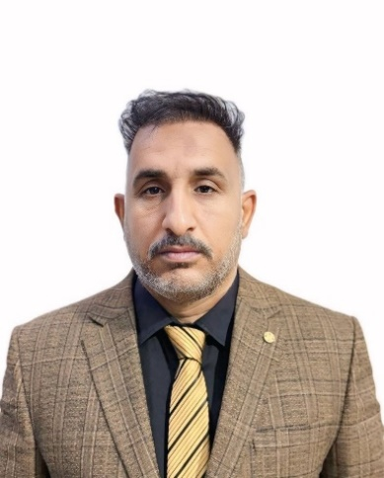
 | Accountant - Finance and Auditing | General and precise specialization
 | Shatt Al-Arab University College - Director of Quality | The current workplace
 | More than 2 years in University Shatt Al-Arab College | University service
 | Wissam.Noory@sa-uc.edu. | work email :
 | 07726666460 | Telephone number
 | assistant teacher. | The scientific title
No thing |  |  | Scientific Excellence
-

Scientific biography
- Master of Accounting in 2022 from the University of Karbala  - Bachelor’s degree in Accounting in 2017 from Shatt Al-Arab University College | scientific certificates
Retired from the Ministry of Interior | Previously held jobs
Financial accounting - intermediate accounting - cost accounting - accounting principles | Scientific interests
E-learning and its famous software (Zoom - Google Classroom - YouTube - and PowerPoint) | Software experience
No thing | Supervision of postgraduate students
More than (2 ) | Published Research
No thing | Scientific Committees
No thing | Development committees in the department and college
No thing | Training
No thing | Scientific Conferences
No thing | Community Service
No thing. | Scientific contributions to the development of the Iraqi economy
No thing. | Thanks Books

