Personal Information

Full Name and Title |  |  | Aseel Jassim Mohammed Al-Abd Al-Sayed |  |  | 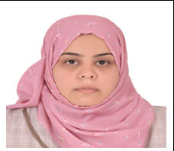
Date of Birth |  |  | 1990
Place of Birth |  |  | Basra
Nationality |  |  | Iraqi
Marital Status |  |  | Single
Number of Children
Address |  |  | Basra/Basra/Al-Hussein neighborhood
Email |  |  | Aseel.jasim@sa-uc.edu.iq
Phone |  |  | 07714435515
Academic Title |  |  | Assistant Lecturer
General Specialization |  |  | Computer Science
Specific Specialization |  |  | Wireless Sensor Network Security
Current Specialization |  |  | Teaching

Degrees and Academic Titles
Degree | Date of Degree |  |  | Thesis/Dissertation Title | University |  | Country
PHD
Master’s Degree | 2024/1/27 |  |  | Security Enhancement of Wireless Sensor Networks based on Chacha20 and Simon Algorithms | Basra |  | Iraq

Skills
Skills
Arabic Language |  | 90%
English Language |  | 70%
Other Languages

Research Activity

Cultural Activities (Participation in Conferences, Seminars, etc.)
Activity Name | Location and Date

Awards, Acknowledgments, and Certificates of Appreciation for the Academic Year
Reason for Award | Issuing Authority | Date | Certificate

Teaching Experience
Academic Level | Courses Taught
Third Stage | Software engneering
Number of Theses/Dissertations Supervised | Supervision of Graduate Studies

