Personal Details
Name | ALAULDDIN ABDULWAHHAB HASSOON AL-SABTI |  |  |  |  |  | 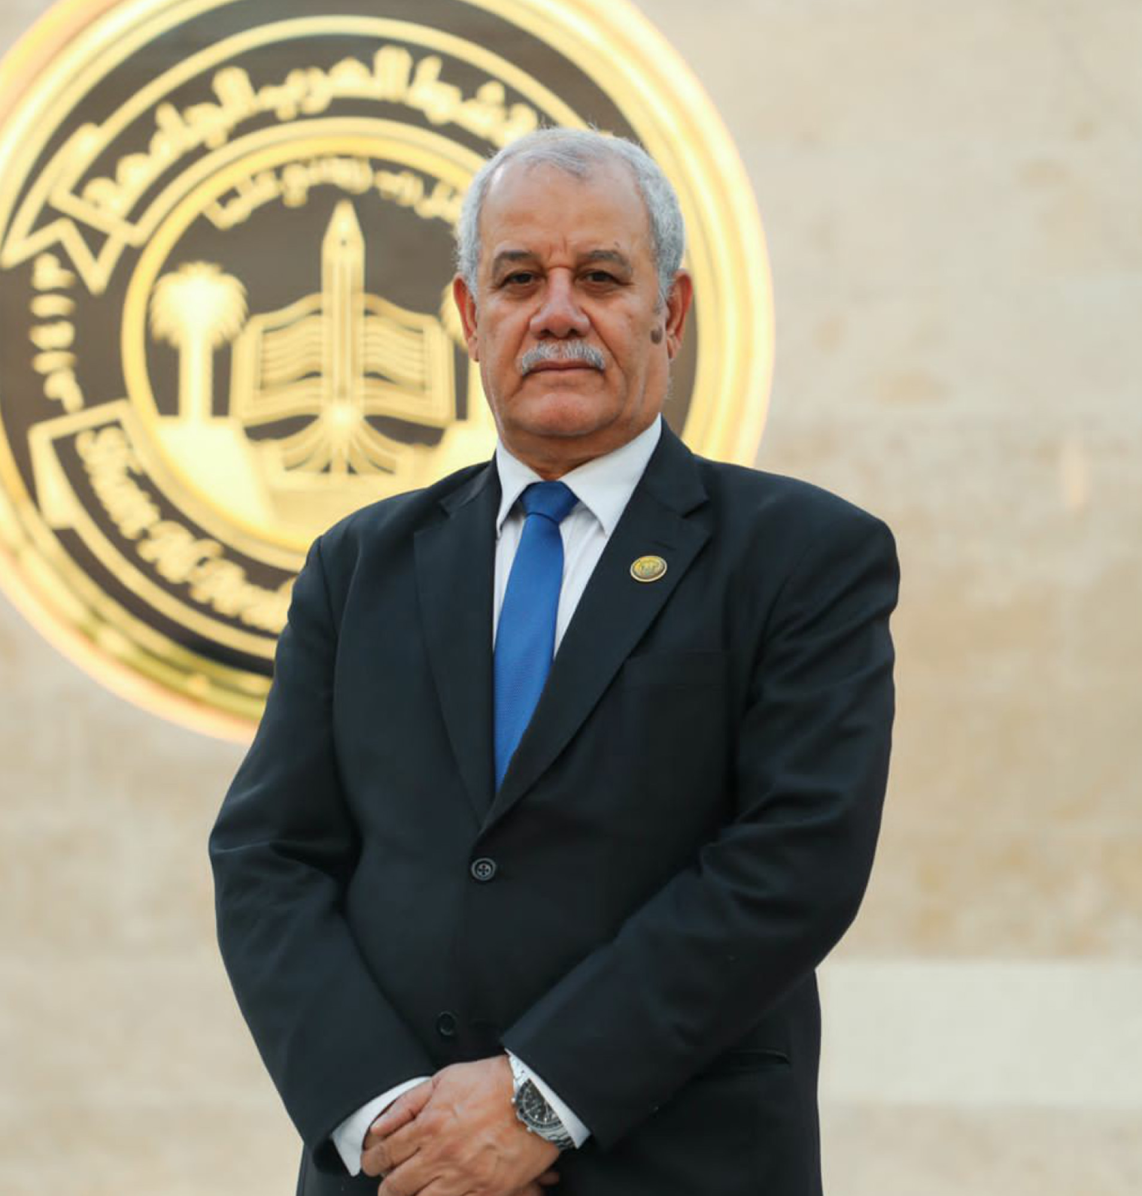
Email | Aalsabti1@gmail.com
Phone Number | 07727916108 / 07854545534
Address | SHATT AL-ARAB UNIVERSITY COLLEGE / Accounting Department
Education
Certificate | Date | University |  |  | Country
Bachelor Degree | 16/7/1977 | Basra university |  |  | Iraq
PhD | 10/10/1997 | Baghdad university |  |  | Iraq
Languages
English | Good
Arabic | Mother language
Other
Training Courses/ Workshops
Title | Date |  | Period |  |  | Country
Teaching Methods course | Erbil/ Cihan Private university/2012 |  | Two weeks |  |  | Iraq
Computer skill course | Ministry of Higher education and Scientific research/ 2021 |  | Electronic |  |  | Iraq
Techno economic and visibility studies | Administrative Development Centre  Baghdad  1992 |  | Two weeks |  |  | Iraq
Scientific Research
Title |  |  |  | Place & Date of Publication
1-Accounting Information Processing / Accounting Commitment – relation and difference  2- Investment on common stock based on profitability and market indicators A field study in industrial companies mixed sector  3- A content of the added economic value to measure the profitability of Jordanian industrial companies  4- Performance Evaluating of Omani Insurance companies / A field study  5- The optimum production mix between the marginal return and theory of constraints / A field study in an Omani company  6- Challenge Facing the profession of Accounting and Auditing in the Sultanate of Oman  7-Corporate Governance and its Effect on Supervision and guidance / A field study in the Capital Market Authority of the Sultanate of Oman  8- Accounting on the Basis of value added / A field study in Omani Industrial companies  9- Financial accounting Practices in small Enterprises  - 10- An Effect of accounting conservatism on the performance of Omani insurance companies.  - 11- Does earning management tend to the accrual basis against the cash flow basis?  - 12- The effect of the elements of corporate governance of Companies social responsibility / A field study in the Iraqi private commercial Banks  - 13- Factors affecting students` perceptions in the decision the accounting major / A field study at Cihan private university / Erbil / Iraq 2016  - 14-Measurement and disclosure in the activity of Musharkat and Musharkat motniagisa in Islamic Banks/ A field study in Elaf Islamic  - 15- An effect of accounting profits and cash flows on the performance of joint stock companies / A field study in Omani joint stock companies / A joint research presented to the Cihan university conference 2014  - 16- Analysis of the relationship of ethics and source and power / a survey in insurance brokers in Bahrain.  - 17- A voluntary disclosure of human capital / A field study of Omani companies listed on the Muscat Securities An effect of/ research presented to the joint conference between the European Group for public administration, Aix- Marseille university and the Middle east and North Africa network for the public administration (MENAPAR)/ 2017.  18- Revenue recognition according to International Financial Reporting standards No. 15 / A field study in Commercial Private Banks / Al- Mustansirya Journal / 2021  19- Problems expected for the application of International Financial Reporting Standard No. (9) / A field study in Iraqi private commercial banks / journal of economic and admiration college / Basrah university / 2022.  20- The relationship between the reputation of audit offices and the accuracy of the opinion on continuity and the extent to which it is affected by the financial failure field research in the Iraqi Stock Exchange  21- Impact of human resources accounting on the market value and evaluation of the company's financial performance  A field study on a sample of Iraqi companies listed in the Iraq Stock Exchange  (On evaluation)  - An effect of auditor experience and other factors on fair value estimates on professional skepticism  A field study on a sample of auditors in Iraq.  (On evaluation)  - An effect of tax avoidance on the cost of capital  Using company size, financial leverage, rate of return on assets, and operating cash flows as intermediate variables  A field study on a sample of companies listed on Iraq and Kuwait Stock Exchange  ( on evaluation) |  |  |  | journal of Al- Rafdian College university / Baghdad 1999  Journal of Economic and administrative Science / university of Baghdad / 1999  journal of Darsat / the University of Jordan / Amman /2003  Al- El- Dari Omani Journal / Muscat 2003  Al- Edari Journal / Muscat 2004.  Al Balqa Journal research and studies / Al–Ahilyya Amman university/ Amman 2005  Journal of Economic and legal Science / Damascus university 2006  journal of Babel university for conomic and administrative Science /2017  a joint research 2016  Babylon Journal 2017  A joint research presented to the Cihan university conference 2014  - A joint research presented to the conference on advanced business administration and information technology held in Paris for the period 12-13 September 2019.  Al- Mustansirya Journal / 2021  Journal of economic and admiration college / Basrah university / 2022.  International journal of professional Business review vol.7 No. 2 pp1-23  2022  2023  2023  2023

