Personal Information

Full Name and Title |  |  | Mustafa Sobhi Salman Kazim Al-Atabi |  |  | 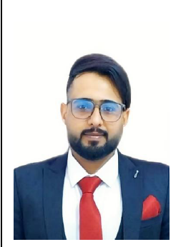
Date of Birth |  |  | 1993/5/21
Place of Birth |  |  | Basra
Nationality |  |  | Iraqi
Marital Status |  |  | married
Number of Children |  |  | 2
Address |  |  | Basra - Abi Al-Khaseeb
Email |  |  | mustafa.subhi@sa-uc.edu.iq
Phone |  |  | 07719801004
Academic Title |  |  | Assistant Lecturer
General Specialization |  |  | Computer Science
Specific Specialization |  |  | Information Technology Engineering
Current Specialization |  |  | Teaching

Degrees and Academic Titles
Degree | Date of Degree |  |  | Thesis/Dissertation Title | University |  | Country
PHD
Master’s Degree | 2023 |  |  | A new fault detection method for wireless sensor networks using Autoencoder and LS-SVM | Qom University |  | Iran

Skills
Skills
Arabic Language |  | 100%
English Language |  | 100%
Other Languages |  | Persian

Research Activity
A new fault detection method for wireless sensor networks using Autoencoder and LS-SVM
A new fault detection method for wireless sensor networks using lstm_ attention

Cultural Activities (Participation in Conferences, Seminars, etc.)
Activity Name | Location and Date

Awards, Acknowledgments, and Certificates of Appreciation for the Academic Year
Reason for Award | Issuing Authority | Date | Certificate

Teaching Experience
Academic Level | Courses Taught
Third Stage | Data structures
Number of Theses/Dissertations Supervised | Supervision of Graduate Studies

