Personal Information
Full Name and Surname | Hussein Nasser Khlaf Sayah Al-Salman |  |  |  |  | 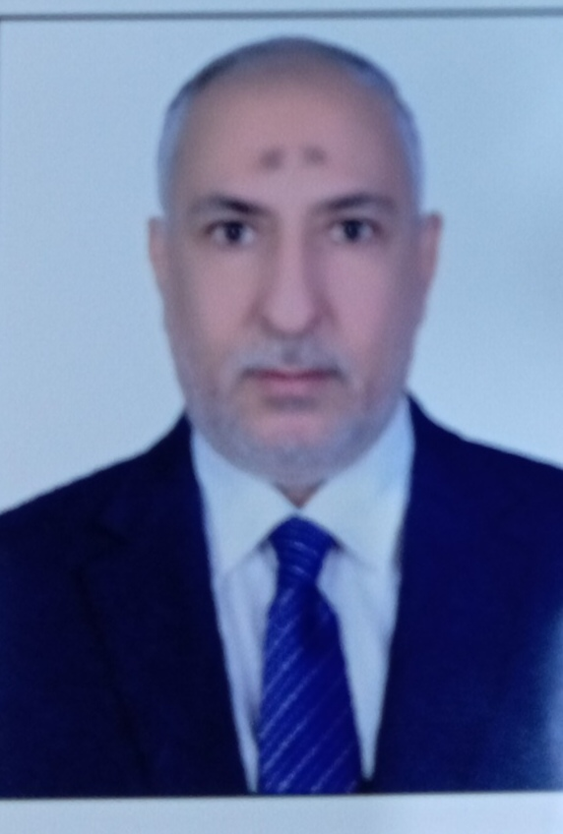
Date Of Birth | 1970
Place of Birth | Basra, Iraq
Nationality | Iraq
Marital Status | married
Number of Children | 4
Address | Basra / University Housing, University of Basra
Email Address | hsennaserh@yahoo.com
Mobil Number | 07702683703
Scientific Title | Professor Dr.
General specialty | Chemistry/
Exact Specialty | Pharmaceutical Analytical Chemistry
Recent Specialty | Pharmaceutical Analytical Chemistry/Medical Physics
Certificates and Academic Titles
Certificate | Date | Title Name |  |  | University |  | Country
Ph.D. | 2016 | Pharmaceutical analytical chemistry |  |  | University of Basra |  | Iraq
Master Degree
Skills
Shills
Arabic language
English Language | Reading books and references in both Arabic and English in the field of general and specific specialization, as well as reading novels in English and Arabic.
Other Languages
Training Courses
Course Name | Course Location |  | Course Duration | Course Date
 |  |  | no
Administrative Positions
Employments (Starting from Recent ) |  |  | From | to
no |  |  | no | no

Research Activity
# I have 106 research papers published in international journals, Scopus and Clarbet.
# I have three published medical books.
3 I have five patents in the medical and chemical fields.

Cultural Activities (Participation in Conferences, Seminars, etc)
Activity Name |  | Place and Date
 |  | Numerous participations inside and outside Iraq, reaching 40 participations during my work as a university professor.
Awards, Certificates of Appreciation for the Academic Year
Certificate | Dates | Place of Award | Reason for award
 |  |  | More than 280 certificates of appreciation from international journals, conferences, the Ministry of Higher Education and Scientific Research, and the Presidency of the University of Basra.

Teaching Experiences
Subject you taught | Academic stage
 | The first and fifth stages in the College of Fishing at the University of Basra. The first stage in the College of Science at Shatt al-Arab University.
Postgraduate supervision | Number of Theses or Dissertations
 | 22 postgraduate students in various fields, Masters and Doctorate

