Personal Information

Full Name and Title |  |  | Mohammed Asaad Hussein Sekhi |  |  | 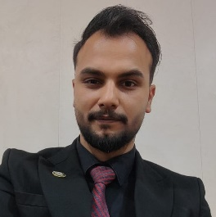
Date of Birth |  |  | 1997/1/1
Place of Birth |  |  | Basra
Nationality |  |  | Iraqi
Marital Status |  |  | Single
Number of Children
Address |  |  | Basra
Email |  |  | muhamad.asad@sa-uc.edu.iq
Phone |  |  | 07713171213
Academic Title |  |  | Assistant Lecturer
General Specialization |  |  | Computer Science
Specific Specialization |  |  | Cipher Security
Current Specialization |  |  | Teaching

Degrees and Academic Titles
Degree | Date of Degree |  |  | Thesis/Dissertation Title | University |  | Country
Master’s Degree | 2022 |  |  | File security using image-based encryption (FSUIE)‏ | Altinbas |  | Turkey

Skills
Skills
Arabic Language |  | 100%
English Language |  | 100%
Other Languages

Research Activity
- File security using image-based encryption (FSUIE)‏.
- File encryption based on the process of comparing locations and values between images and a text file.

Cultural Activities (Participation in Conferences, Seminars, etc.)
Activity Name | Location and Date

Awards, Acknowledgments, and Certificates of Appreciation for the Academic Year
Reason for Award | Issuing Authority | Date | Certificate

Teaching Experience
Academic Level | Courses Taught
Second Stage | Probability and statistics
First Stage | Computer Principles
Number of Theses/Dissertations Supervised | Supervision of Graduate Studies

