Personal Details
Name | Wurood Qusay Anghimish Al-Hattab |  |  |  |  |  |  |  |  |  |  | 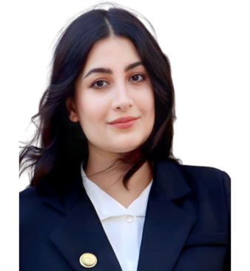
Email | wurood.qusay@sa-uc.edu.iq
Phone Number
Address | Basra – Abu Al-Khaseeb District
Education
Certificate |  | Date |  |  | University |  |  |  | Country
Master’s in English language and literature |  | 2021 |  |  | Yeni Yüzyıl |  |  |  | Turkey
Languages
Arabic  English |  | Arabic: Advanced  English: Advanced
Training Courses/ Workshops
Title |  |  |  | Date |  |  |  |  |  |  | Period |  |  | Country
Teaching Methods |  |  |  | 20/11/2022 |  |  |  |  |  |  | Five Weeks |  |  | Iraq
Teaching Experience
Title |  |  |  |  |  |  | From |  |  |  |  |  | To
Teaching Staff at Shatt Al-Arab University College |  |  |  |  |  |  |  | 10/09/2023 |  |  |  |  | Till Present
Head of Media Unit |  |  |  |  |  |  |  | 28/08/2024 |  |  |  |  | Till Present
Scientific Research
Title |  |  |  |  |  |  |  |  |  | Place & Date of Publication
Awards and Certificate of Appreciation
Certificate |  |  | Date |  |  | Issued by
Appreciation and Recognition |  |  | 15/04/2022 |  |  | Lotus Cultural and Feminist Association
Teaching Experience
Subject |  |  |  |  |  |  |  |  |  | Stage
Novel |  |  |  |  |  |  |  |  |  | Fourth Year
literature |  |  |  |  |  |  |  |  |  | First Year
Drama |  |  |  |  |  |  |  |  |  | Second Year
Crimes of the Baath Party |  |  |  |  |  |  |  |  |  | Second Year
Research Methodology |  |  |  |  |  |  |  |  |  | Third Year
Writing |  |  |  |  |  |  |  |  |  | Second Year

