Personal Details
Name | Fadel Ismail Khalil Al-Aboud |  |  |  |  |  |  |  |  | 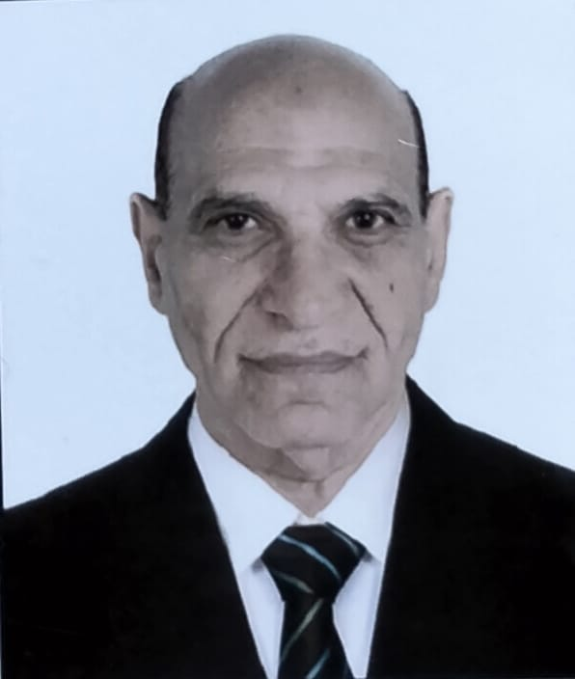
Email | althairalabadi@gmail.com
Phone Number | 07729085480
Address | Al-jameea district
Education
Certificate |  | Date |  |  | University |  | Country
PhD |  | 19/5/1998 |  |  | Baghdad |  | Iraq
M.A. |  | 6/11/1990 |  |  | Baghdad |  | Iraq
Languages
English
Arabic
Training Courses/ Workshops
Title |  |  |  | Date |  |  |  |  | Period |  | Country
Open Development Course 23 |  |  |  | 21/12/1992 |  |  |  |  | 3 days |  | iraq
The seventh open qualifying course |  |  |  | 18/1/1992 |  |  |  |  | 3 days |  | Iraq
Scientific Research
Title |  |  |  |  |  |  |  | Place & Date of Publication
Awards and Certificate of Appreciation
Certificate |  |  | Date |  |  | Issued by
Thanks and appreciate |  |  | 12/12/2016 |  |  | University of Basra
Thanks and appreciate |  |  | 14/1/2015 |  |  | University of Basra
Thanks and appreciate |  |  | 3/1/2011 |  |  | University of Mosul
Thanks and appreciate |  |  | 9/12/2010 |  |  | General Secretariat of the Central Library
Thanks and appreciate |  |  | 12/12/2013 |  |  | Deanship of the College of Education / University of Maysan
Thanks and appreciate |  |  | 24/1/2000 |  |  | Deanship of the Faculty of Arts
Thanks and appreciate |  |  | 4/4/2008 |  |  | Deanship of the Faculty of Arts
Thanks and appreciate |  |  | 5/1/2009 |  |  | Deanship of the Faculty of Arts
Thanks and appreciate |  |  | 24/10/2010 |  |  | University of Basra
Thanks and appreciate |  |  | 24/3/2010 |  |  | Deanship of the College of Jurisprudence / University of Kufa
Thanks and appreciate |  |  | 18/10/2010 |  |  | Deanship of the College of Jurisprudence / University of Kufa
Thanks and appreciate |  |  | 23/12/2010 |  |  | Deanship of the College of Jurisprudence / University of Kufa
Thanks and appreciate |  |  | 20/2/2012 |  |  | University of Basra
Thanks and appreciate |  |  | 14/1/2014 |  |  | Deanship of the College of Jurisprudence / University of Kufa
Teaching Experience
Subject |  |  |  |  |  |  |  | Stage
Quran and Hadith Sciences |  |  |  |  |  |  |  | First-third
Analysis of the Quranic text |  |  |  |  |  |  |  | Third
Arabic for non-specialists |  |  |  |  |  |  |  | First

