CURRICULUM VITAE

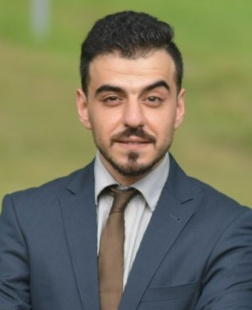
- PERSONAL INFORMATION

Name : Hussein fouad abbas almazini
Nationality : Iraqi
Date of Birth : August 5 1990
Marital Status : Single
Current address : Basra - Iraq
Mobile Number : +964-773670080
Email : h.almazni22@gmail.com

- ACADEMIC QUALIFICATION

B.Sc. Computer science, 2009 - 2013
Shatt Al Arab University College, Basra, Iraq

M.Sc. Information Technology, 2016 - 2018
Universiti Utara Malaysia, Kedah

Ph.D Information Technology, currently, I'm studying toward a Ph.D. degree.
Universiti Utara Malaysia, Kedah

- PERSONAL PARTICIPATION

1. English language proficiency certificate
2. 8th International conference on computing & informatics (ICOCI 2021)

- AREA OF RESEARCH

Artificial intelligence, evolutionary computation, meta-heuristic algorithms ,swarm intelligence and deep learning. As well as mining scientific datasets in domains such as IoT, healthcare, cyber security, social network, business, demographic, sustainability, and intelligence analysis

- My Account on Different Websites

Google Scholar

https://scholar.google.com/citations?user=H-uZYJoAAAAJ&hl=en

ResearchGate

https://www.researchgate.net/profile/Hussein-Almazini

- PUBLICATION

- Hussain, A., Mkpojiogu, E. O., Almazini, H., & Almazini, H. (2017, October). Assessing the usability of Shazam mobile app. In AIP Conference Proceedings (Vol. 1891, No. 1, p. 020057). AIP Publishing LLC.
- Almazini, H., & Ku-Mahamud, K. R. (2021). Grey Wolf Optimization Parameter Control for Feature Selection in Anomaly Detection. International Journal of Intelligent Engineering and Systems, 14(2), 474-483.

- Almazini, H. F., Mortada, S., Al-Mazini, H. F. A., Khraibet, H. N., & AL-Behadili, J. A. (2022). Improved discrete plant propagation algorithm for solving the traveling salesman problem. Int J Artif Intell, 11(1), 13-22.

Languages | Speaking | Writing | Reading | Listening
Arabic | Native | Native | Native | Native
English | Good | Good | Good | Good

