Personal Details
Name | Salma Abdul Hussein |  |  |  |  |  |  |  |  |  |  | 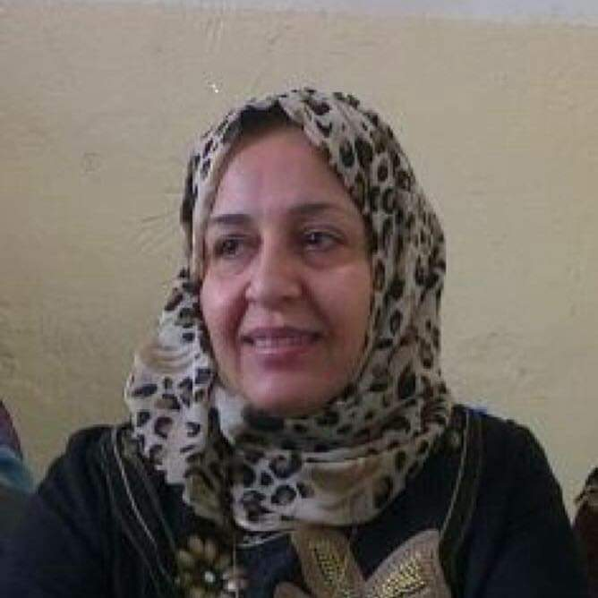
Email | Salma.abdulhussain@sa-uc.edu.iq
Phone Number | 07802296087
Address | Al- Wufood Street
Education
Certificate |  | Date |  |  | University |  |  |  | Country
M.A English literature |  | 1/9/2024 |  |  | Basrah |  |  |  | Iraq
B.A English language & literature |  | 2019-2020 |  |  | Basrah University |  |  |  | Iraq
Languages
Arabic |  | Arabic
English |  | English
Training Courses/ Workshops
Title |  |  |  | Date |  |  |  |  |  |  | Period |  |  | Country
Teaching English as a Second Language |  |  |  | 2017 |  |  |  |  |  |  | Three months |  |  | U.S.A
British Council Certificate  Writing Training Course of Creative writing |  |  |  | 1968-1991  2018 |  |  |  |  |  |  | 4 years  Three Months |  |  | British Council in Baghdad  Online course with Oregon University
Teaching Experience
Title |  |  |  |  |  |  | From |  |  |  |  |  | To
Academic coordinator in Al- Awhad Schools |  |  |  |  |  |  |  | 2022 |  |  |  |  | 2024
Teaching Supervisor at Al-Adreesi Private Schools |  |  |  |  |  |  |  | 2017 |  |  |  |  | 2018
Teacher at Al-Farahedi Private Schools |  |  |  |  |  |  |  | 2011- |  |  |  |  | 2017
Teacher at Pakestani School( Libya) |  |  |  |  |  |  |  | 2000 |  |  |  |  | 2014
School Principal at Asian English Medium School |  |  |  |  |  |  |  | 1996 |  |  |  |  | 1998
Teacher at Asian English Medium School |  |  |  |  |  |  |  | 1993 |  |  |  |  | 1995
Scientific Research
Title |  |  |  |  |  |  |  |  |  | Place & Date of Publication
The Carnivalesque in Hari Kunzru’s God’s Without Men and Emily St. John Mandel’s The Glass Hotel: A Abakhtinian Reading / Critique Studies in Contemporary Fiction ( Scopus ). |  |  |  |  |  |  |  |  |  | Critique Studies in Contemporary Fiction ( Scopus ). 2024
Polyphony and Dialogism in Hari Kunzru’s God’s Without Men/ |  |  |  |  |  |  |  |  |  | Basra Literature Magazine 2024
Awards and Certificate of Appreciation
Certificate |  |  | Date |  |  | Issued by
Teaching Experience
Subject |  |  |  |  |  |  |  |  |  | Stage

