Personal Details
Name | Mazin Abdulelah Alawan |  |  |  |  |  |  |  | 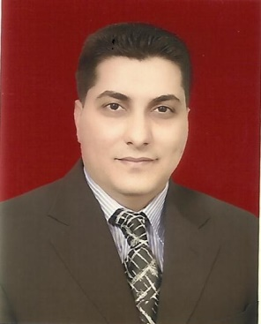
Email | drmazinalwan@gmail.com, drmazinalwan@sa-uc.edu.iq
Phone Number | 009647712633448
Address | Iraq-Basrah
Education
Certificate | Date |  | Thiess title |  |  |  |  |  |  | University
Ph.D of Electrical Eng. | 2012 |  | Modeling, Fabrication, and Control of HB-type Vernier Motor |  |  |  |  |  |  | University of Basrah, Iraq
M.Sc of Electrical Eng. | 2002 |  | Design and implementation of digital differential protection for three-phase power transformer |  |  |  |  |  |  | University of Basrah, Iraq
Languages
English | V.good
Arabic | V.good
Other
Training Courses/ Workshops
Title |  | Date |  |  | Period |  | Country
Modern teaching skills |  | 2017 |  |  | 15-20 Jul |  | Lebanon
Develop teaching skills |  | 2019 |  |  | 16-21 Feb |  | Italy
Managerial Position
Title |  |  |  | From |  |  |  | To
Department rapporteur |  |  |  | 2014 |  |  |  | 2018
Head of the Department |  |  |  | 2018 |  |  |  | 2019
Scientific Research
Title |  |  |  |  |  | Place & Date of Publication
Simulation and Experimental Verification of a HB-Type Vernier Motor |  |  |  |  |  | ETASR - Engineering, Technology & Applied Science Research. Vol. 3, No. 1, 2013
Simulating an induction motor multi-operating point speed control using PI controller with neural network |  |  |  |  |  | Periodicals of Engineering and Natural Sciences. Vol 7, No 3. 2019
Design of intelligent distance relay for cascaded transmission lines fault detection based on fuzzy logic system |  |  |  |  |  | Periodicals of Engineering and Natural Sciences. Vol 8, No 2. 2020
Numerous speeds-loads controller for DC-shunt motor based on PID controller with on-line parameters tuning supported by genetic algorithm |  |  |  |  |  | Indonesian Journal of Electrical Engineering and Computer Science. Vol 21, No 1. 2021
Awards and Certificate of Appreciation
Certificate | Date |  |  |  |  | Issued by
Thanks and appreciation | 21/9/2021 |  |  |  |  | Dean of Shatt Al Arab College
Thanks and appreciation | 21/12/2020 |  |  |  |  | Dean of Shatt Al Arab College
Teaching Experience
Subject |  |  |  |  |  | Stage
Electrical circuits |  |  |  |  |  | 1st
Engineering Analysis |  |  |  |  |  | 3rd
Architecture and assembly language |  |  |  |  |  | 2nd
Computer architecture |  |  |  |  |  | 3rd
Operating system |  |  |  |  |  | 4th
Electrical machines |  |  |  |  |  | 2nd
Information theory |  |  |  |  |  | 3rd
Operations research and statistics  Digital electronic |  |  |  |  |  | 3rd  3rd
Digital communication |  |  |  |  |  | 4th
Intelligent applications |  |  |  |  |  | 4th
Intelligent control |  |  |  |  |  | 4th
Microprocessor |  |  |  |  |  | 2nd

