

**University : Shatt Al-Arab College**

**University College : Shatt Al-Arab University College**

**Department : Department of Fuel and Energy Technologies Engineering Stage :Second**

**Lecturer Triple Name : M.s.c Ali Saad Eddin Abdel Hamid**

**Scientific Title :M.s.c**

**Qualification : Master**

**Work Place : Shatt Al Arab University**

Republic of Iraq Ministry of Higher Education and Scientific Research Scientific Supervision and Evaluation Authority

**Weekly class schedule**

|  |  |  |  |  |  |
| --- | --- | --- | --- | --- | --- |
| **the name** | **Mr. Ali Saad El-Din Abdel Hamid** | | | | |
| **e-mail** | **ali.saadaldeen@sa-uc.edu.iq** | | | | |
| **Name of the material** | **Mathematics 3** | | | | |
| **Semester Schedule** | **annual** | | | | |
| **General objective of the course** | year students of the Fuel and Energy Engineering Technology Department ( 270 ) were enabled in the morning study to understand differential and integral calculus, partial differentiation, complex numbers, vectors, and polar coordinates. It also aims to teach students to solve first-order and higher-order differential equations and to use matrices to solve linear systems. | | | | |
| **Specific objectives** | • 1. Develop problem-solving skills and understanding of differential and integral calculus.  2. Understand vectors, vector function and their applications.  3. Identify complex numbers and apply them in mathematical problems.  4. Apply partial differentiation and solve problems with multiple variables.  5. Learn and use double and polar integration to calculate areas and volumes.  6. Understand theories such as Green’s Theorem and Divergence Theorem and use them in engineering applications.  7. Solve first-order and higher-order differential equations. | | | | |
| **Textbooks** | **Calculus and Analytic Geometry" by G. Thomas and R. Finney, Sixth Edition, 2008.** | | | | |
| **External sources** | **• “Mathematical Methods for Science Students” by G. Stephenson, Longman House, 1981.** | | | | |
| **Chapter Estimates** | **Semester** | **The laboratory** | **Daily exams** | **The project** | **Final Exam** |
| **15** | **-** | **3** | **-** | **60** |
| **Additional information** |  | | | | |



**University : Shatt Al-Arab College**

**University College : Shatt Al-Arab University College**

**Department : Department of Fuel and Energy Technologies Engineering Stage :Second**

**Lecturer Triple Name : M.s.c Ali Saad Eddin Abdel Hamid**

**Scientific Title :M.s.c**

**Qualification : Master**

**Work Place : Shatt Al Arab University College**

Republic of Iraq Ministry of Higher Education and Scientific Research Scientific Supervision and Evaluation Authority

**Weekly class schedule**

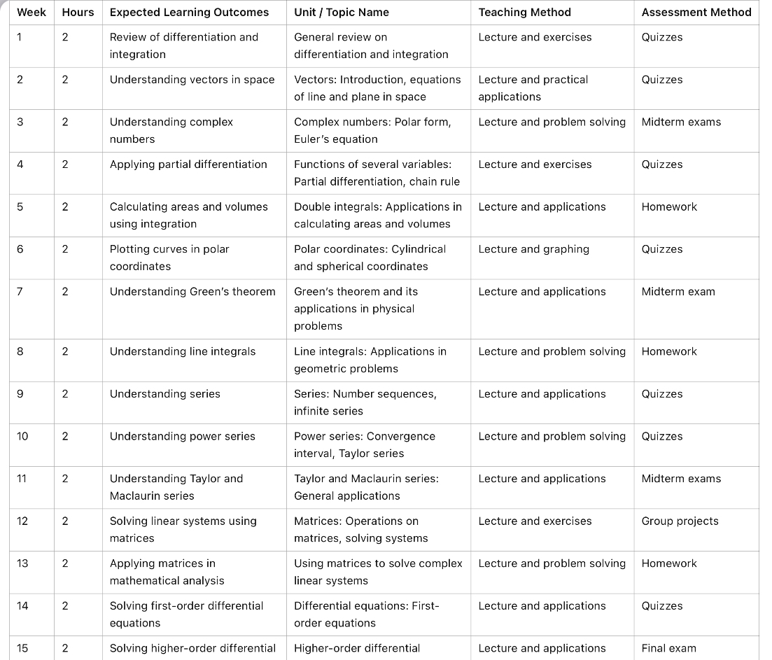

**Professor's signature: Head of Department's signature:**