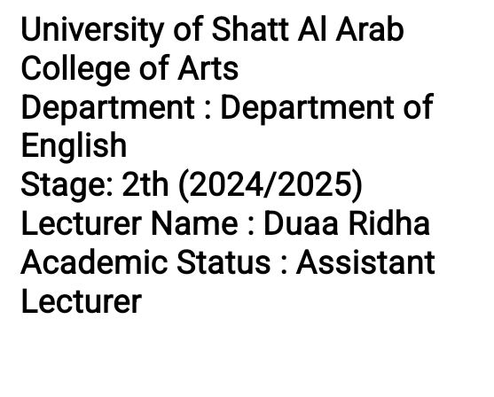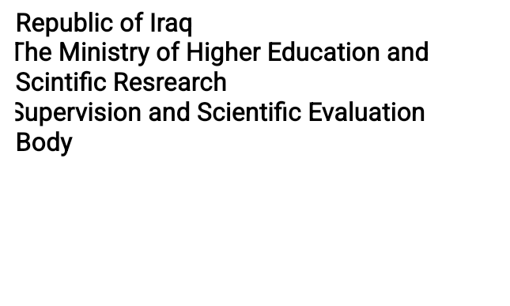

**Course Weekly Outline**

| **Duaa Ridha** | | | | **Course Lecturer** |
| --- | --- | --- | --- | --- |
| [**duaa.ridha@sa-uc.edu.iq**](mailto:duaaridha@sa-uc.edu.iq) | | | | **e-mail** |
| **Writing** | | | | **Title** |
| **Duaa Ridha** | | | | **Course Coordinator** |
| **This course aims to develop students' writing skills, enabling them to express their ideas clearly and in an appropriate language. It also focuses on fostering critical thinking skills during the writing process. This includes understanding the fundamentals of language and grammar and applying them in organizing logical and coherent texts. The goal further involves enhancing research skills and effectively utilizing sources to support writing. Additionally, the objective is to encourage effective verbal communication and promote creativity and diversity in writing styles.** | | | | **Course Objective** |
| **In this course, we aim to develop students' writing skills, enabling them to express themselves clearly and in a refined language. This includes understanding the basics of language and grammar and applying them in writing. We also seek to enhance critical thinking, foster research skills, and effectively use sources. Emphasis is placed on effective verbal communication, as well as promoting creativity and diversity in writing styles. Ultimately, our goal is to achieve academic writing objectives for students, enhancing their capabilities to engage with linguistic and academic challenges.** | | | | **Course Description** |
| **Academic Writing from paragraph to essay Perfect Paperback – August 9, 2010**  **German Edition by Dorothy E Zemach (Author), Lisa Rumisek (Author)** | | | | **Textbook** |
|  | | | | **References** |
| **Final Exam** | **Quizzes and Attendance** | **Project** | **Term Exam** | **Course Assessment** |